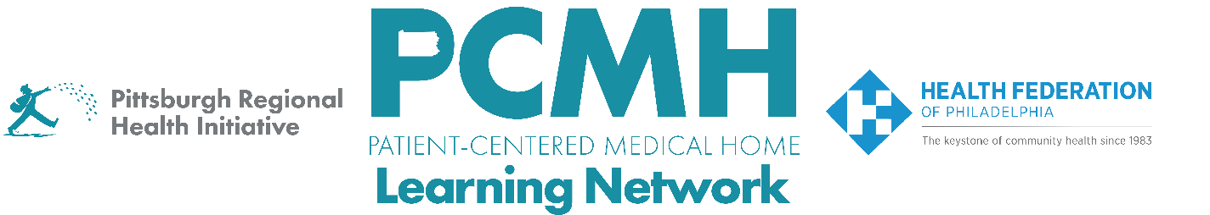

HealthChoices PCMH Learning Network
Well-Child and Adolescent Well-Care Visits Interventions

Session #1 – Wednesday, March 26th at 9:30-11 a.m. via Zoom

Learning Objectives:

- Describe the goals of the Well-Child and Adolescent Well-Care Visits Intervention sprint
- Discuss effective strategies for engaging youth and adolescents in well-care visits.
- Describe workflow processes and team roles for adolescent sexual health screening.
- Discuss how PCMHs in Pennsylvania are implementing key interventions for Well-Child and Adolescent Well-Care Visits.

Agenda:

9:30 a.m. to 9:40 a.m. – Welcome & Overview of the Well-Child and Adolescent Well-Care Visits Interventions Sprint – Robert Ferguson, MPH, Chief Policy Officer, Pittsburgh Regional Health Initiative

9:40 a.m. to 10:20 a.m. – Guidelines and Effective Strategies for Adolescent Well-Care Visits and STI Screenings – Elizabeth Miller, MD, PhD, Adolescent and Young Adult Medicine at UPMC Children’s Hospital of Pittsburgh, Distinguished Professor of Pediatrics at University of Pittsburgh School of Medicine

10:25 a.m. to 10:30 a.m. – Results from the Well-Child and Adolescent Well-Care Visits Interventions Sprint Baseline Survey – Robert Ferguson

10:25 a.m. – 10:55 a.m. – PCMH Peer-to-Peer Learning Discussion

In response to the survey indicating most PCMHs are working on engaging adolescents in well-care visits, PCMHs will have an opportunity to share:

- What steps is your PCMH currently taking?
- What has worked well?
- What challenges are you experiencing?
- To inform your next steps, what would your PCMH team like to learn at the next Well-Child and Adolescent Well-Care Visits Interventions Sprint session on Thursday, May 29th at 1-2:30 p.m. via Zoom

10:55 a.m. – 11:00 a.m. – Next Steps & Wrap Up – Lisa Boyd, Program Specialist, Pittsburgh Regional Health Initiative

