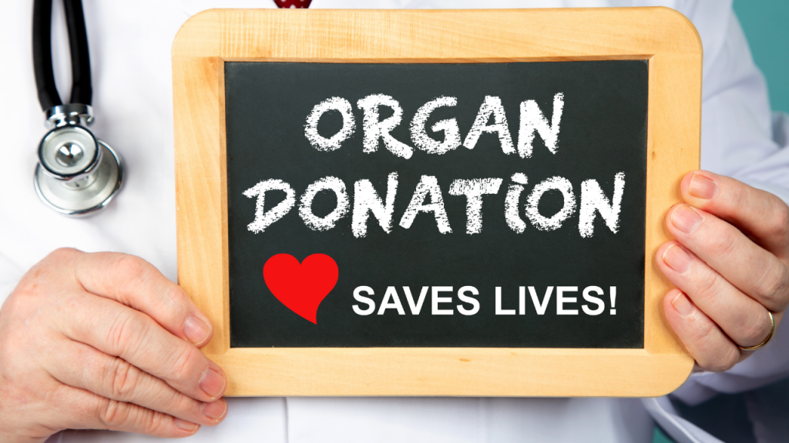  Gift of Life  - In the Trauma Setting  This course is designed to aid staff in effective communication between all on the health care team, including the Transplant coordinators, related to timely referrals of donors and the care of patients through brain death and DCD.  Register by April 18TH  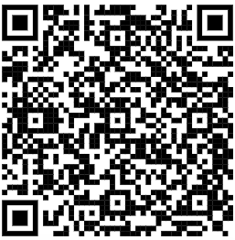  QR CODE HOLD  Registration is not mandatory but strongly encouraged  Questions & additional information: Heidi Weeder- Weederhn@upmc.edu
  April 21, 2025
  8am-10:30am
  Maple-Oak
  Conference Room, UPMC Williamsport
  Speakers:
  Christina Sarge
  GOL Hospital Services Coordinator
  Michael Pearl, PA-C
  Acute Care/Trauma
  TBD
  GOL Transplant Coordinator
  2.5 RN Contact Hours
  American Nurses Credentialing Center (ANCC)
  UPMC Trauma Credit Approved

Gift of Life Trauma Course
Maple Conference Room
April 21, 2025 8:00am

Activity Agenda

8:00am – Welcome & Introductions
Heidi Weeder RN, ICU Senior Clinician,
UPMC Williamsport, Williamsport, PA

8:05am – Connect to Purpose

8:15am - Collaborating for Life: The Donation Process
Christina Sarge, Hospital Services Coordinator,
Gift of Life Donor Program, Philadelphia, PA

8:55am – Determination of Brain Death
Michael Pearl PA-C, Acute Care/Trauma,
UPMC Williamsport, Williamsport, PA

9:35am – Clinical Evaluation & Management of the Potential Organ Donation
TBD, Transplant Coordinator
Gift of Life Donor Program, Philadelphia, PA

10:15am – Open Discussion

10:30am – Closing and Survey

*Times subject to modification based on questions and discussion

