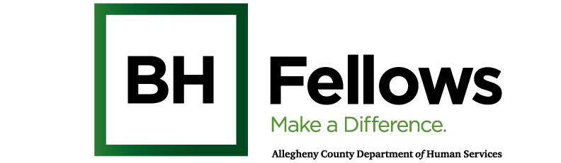

Cohort 4: Good Fellows
Cultural Humility in Behavioral Health (pt. 2)
March 13, 2025
9:00am – 5:00pm

JHF, 25th Floor | 625 Liberty Ave, Ste. 2500, Pittsburgh, PA 15222
Requesting: 2 hours SW Credits

Time | Component | Content | Presenter/Facilitator
8:30 AM | Check-in
9:05 AM | Welcome & Introductions | Review Day’s Agenda  Sanctuary Model Intros  Review Cultural Humility P1  (September 19, 2024) | Bridget McNamee, MID, Behavioral Health Project Manager, Jewish Healthcare Foundation  Jessica Segal, LCSW  Behavioral Health Specialist,  Jewish Healthcare Foundation
9:35 AM | Spotlight | Working with People of All Abilities  Discuss:  - working with and incorporating special needs population  - advocacy work around this population | Kimberly Mathos, DO, MPH  Assistant Professor of Psychiatry,  First Onset Psychosis STEP clinic,  Center for Recovery Services,  UPP services for People who are Deaf, DeafBlind and Hard of Hearing
10:25 AM | Break
10:30 AM | Interactive presentation  1.25 hrs | Putting Cultural Humility into Practice  - BH Fellows individual and group discussion on how to incorporate cultural humility practices in their works  - Develop individual action plans to demonstrate how cultural humility will be applied in day to day work | Julius Boatwright, MSW, LSW  Founder and Managing Director, Steel Smiling
11:45 PM | Lunch | What does BH Fellow’s mean to you?
12:45 PM | QI Activity  .75 mins | Quality Improvement: Tinker Toys  - Demonstrate PDSA QI principles  - 30 minutes in group Activity  - 15 min debrief  - Connect to application of cultural humility (Courtney’s discussion connecting a PDSA/QI approach to Cultural Humility during the debrief | Jennifer Condel  Manager, Lean Healthcare Strategy and Implementation  Jewish Healthcare Foundation
1:30 PM | Breakouts | Applying Cultural Humility: Action Planning Activity | Julius Boatwright  Jennifer Condel  Bridget McNamee
2:30 PM | Healing Practice | Mindful Walk | Jessica Segal, LCSW and Emily Franke, LSW
3:30 PM | Wrap-up and Reminders | Next session: Thurs., May 1 at JHF offices | Bridget McNamee
5:00 PM | Departure

