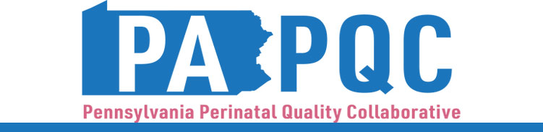

PA PQC Virtual Learning Session
Wednesday, April 16
11:00 a.m. to 12:00 p.m. ET
Virtual

Preparing to Move Initiatives to Sustainment

Learning Objectives:
- Discuss preparation for successfully moving active initiatives into sustainment.
- Identify challenges to sustainment and strategies for overcoming common barriers.

Agenda:

11:00 a.m. to 11:05 a.m. – Welcome – Sara Nelis, RN, C-ONQS, CCE, Program Manager, Jewish Healthcare Foundation

11:05 a.m. to 11:15 a.m. – PA PQC Data Report Out – Q4 2024 – Lisa Boyd, QI Coach & Program Specialist, Jewish Healthcare Foundation & Hadar Re’em, Program Associate, Jewish Healthcare Foundation

11:15 a.m. to 11:35 a.m. – Sustainment Overview – Jennifer Condel, SCT(ASCP)MT, Lead QI Coach, Jewish Healthcare Foundation, Karena Moran, PhD, NEPaPQC Manager, and Sara Nelis, RN, CCE

11:35 a.m. to 11:55 a.m. – Facilitated Discussion – PA PQC Quality Improvement Coaches

11:55 a.m. to 12:00 p.m. – Wrap-up & Next Steps – Sara Nelis, RN, C-ONQS, CCE

