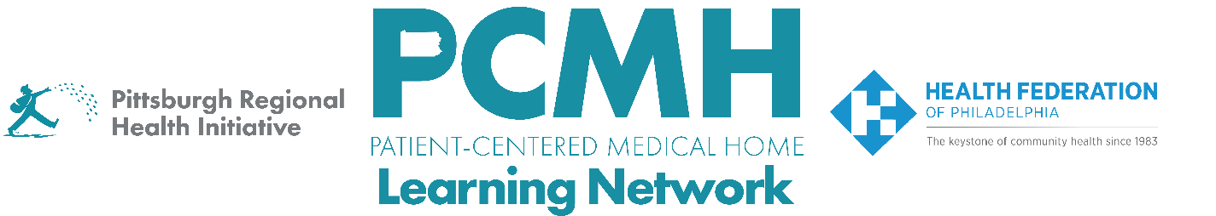

HealthChoices PCMH Learning Network
Social Determinants of Health (SDOH) Interventions

Tuesday, April 22 at 1:00 p.m. to 2:30 p.m. via Zoom

Learning Objectives:

- Describe strategies for PCMHs to develop effective referral partnerships with CBOs
- Describe how to use technology such as PA Navigate (Find Help) to support processes to connect patients to SDOH-related services.
- Discuss PCMH successes and challenges in partnering with CBOs

Agenda:

1:00 p.m. – 1:05 p.m. – Welcome & Session Overview– Robert Ferguson, MPH, Chief Policy Officer, Pittsburgh Regional Health Initiative

1:05 p.m. to 1:50 p.m. – Spotlight: Partnerships and Workflows to Receive and Close the Loop on Referrals

- Sarah Cook, Executive Director, and Latoya Johnson, SFW, Case Management Coordinator, Pittsburgh Community Services, Inc.
- Megan Bair, CEO, and Stacie Snyder, Program Administrator, Central Susquehanna Opportunities, Inc.

1:50 p.m. to 2:00 p.m. – PA Navigate: Connecting Pennsylvanians to Needed Social Services

- Cassandra Donat, Systems Analyst, and Carly Pasinski, Systems Analyst, ClinicalConnect HIE
- Sue Auman, Chief Engagement Officer and Beck Moore, Chief Executive Officer, CAAP

2:00 p.m. To 2:25 p.m. – PCMH Peer-to-Peer Learning Discussion

- How has your PCMH or MCO reached out to and developed referral partnerships with CBOs?
- What has worked well and what hasn’t worked well when making and closing the loop on referrals?
- When your PCMH hears back about the outcome of that referral, how is that documented?
- If your PCMH is using technology, such as PA Navigate or Find Help, how was this tool helped to address past challenges with knowing where to refer patients to and whether the referral was successful?
- Based on what you heard today, what tactics and next steps will you be taking back to your team?

2:25 p.m. to 2:30 p.m. – Next Steps & Wrap Up – Lisa Boyd, Program Specialist, Pittsburgh Regional Health Initiative

