


University of Pittsburgh School of Pharmacy
Spring 2025 Preceptor Continuing Education Seminar

Therapy Updates:
Advances in HIV PrEP l New Treatments for Dermatologic Conditions
Date: Wednesday, May 21, 2025
Time: 6:00 p.m. to 8:00 p.m. EST
Webinar (registration link below)

The goal of this continuing education program is to educate attendees on new therapeutic advances in two rapidly changing areas: HIV prevention, and psoriasis and other dermatologic conditions.


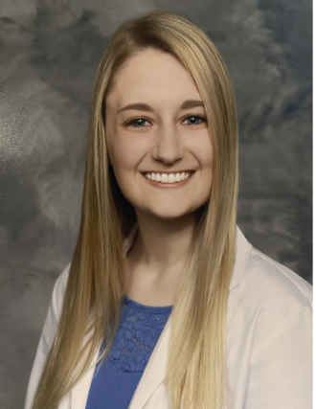

Madelyn Stabinski, PharmD, RPh
Aaron Devanathan, PharmD, PhD, AAHIVP

Program Schedule:
- 6:00pm: Welcome and Introductions
- 6:05-6:55pm: From Plaques to Progress: The Latest Biologic Therapies for Psoriasis
  - Madelyn Stabinski, PharmD, RPh, Ambulatory Care Clinical Pharmacist, Dermatology MTDM Pharmacist, Geisinger Medical Center
- 6:55pm-7:00pm (Break)
- 7:05pm-7:55pm: Advances in HIV Prevention: Are You PrEP-ared?
  - Aaron Devanathan, PharmD, PhD, AAHIVP, Assistant Professor, Department of Pharmacy & Therapeutics, University of Pittsburgh School of Pharmacy.
- 7:55pm: Session Wrap-Up

PRE-REGISTER for this program: https://cce.upmc.com/therapy-updates-advances-hiv-prep-new-treatments-dermatologic-conditions
[Zoom link information will be sent once you are registered for the event. Please email Alison Zappa at aaz13@pitt.edu with questions.]
UPMC Center for Continuing Education in the Health Sciences in association with the University of Pittsburgh School of Pharmacy
In support of improving patient care, the University of Pittsburgh is jointly accredited by the Accreditation Council for Continuing Medical Education (ACCME) and the Accreditation Council for Pharmacy Education (ACPE), and the American Nurses Credentialing Center (ANCC), to provide continuing education for the healthcare team. This knowledge-based activity provides 2.0 contact hours of continuing pharmacy education credit. Other healthcare professionals will receive a certificate of attendance confirming the number of contact hours commensurate with the extent of participation in this activity. JA4008223-0000-24-258-L04-P. Topic designator = 04 General Pharmacy

