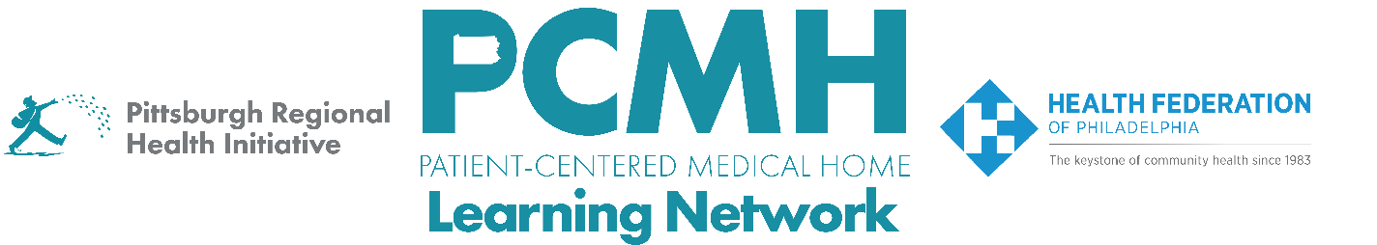
HealthChoices PCMH Learning Network
Post-Hospital Follow-up and Readmission Prevention Sprint
Wednesday, May 7th at 10:30 a.m. – 12:00 p.m. via Zoom

Register: Wednesday, May 7th at 10:30 a.m.-12 p.m. via Zoom

Learning Objectives:

- Describe progress in implementing key interventions.
- Collaborate on finding solutions to common obstacles encountered in implementing interventions.
- Describe best practices for inpatient/outpatient connections in transitions of care.

Agenda:

10:30 a.m. to 10:40 a.m. – Welcome & Review of First Sprint
- Measure definitions
- List of key interventions
- PDSA diagram – where we are

10:40 a.m. to 11:10 a.m. – Breakouts: Intervention Updates
- How were approaches or ideas from the last session incorporated into your processes?

11:10 a.m. to 11:20 a.m. – Takeaways

11:20 a.m. to 11:50 a.m. – Presentation and Q&A: Connecting Inpatient and Outpatient - Leigh Wilson, MSW, Director of Care Management and Redesign Initiatives; Jessica Cordero, Associate Director of Care Management Initiatives; Marisol Caban, Community Health Worker, Camden Coalition of Healthcare Providers

11:50 a.m. to 12:00 p.m. – Sprint Timeline, Next Steps & Evaluation

