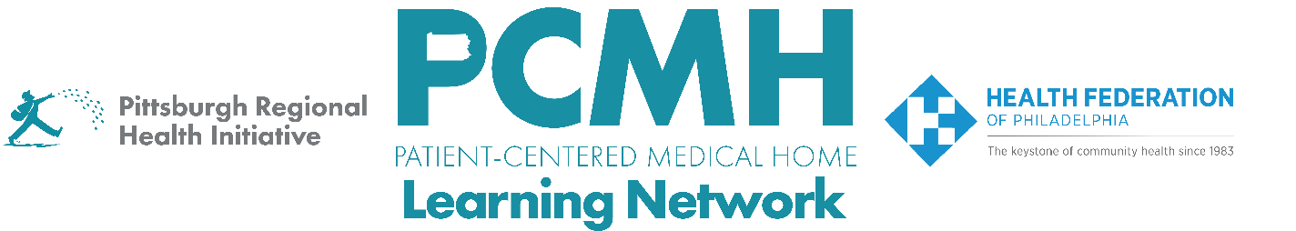

HealthChoices PCMH Learning Network
Pediatric Nursing Care (PNC) Team Sprint

Thursday May 1 at 1:30 p.m. to 2:30 p.m. via Zoom

Learning Objectives:
- Describe care team roles and processes for initiating and maintaining the necessary and authorized services
- Discuss effective examples of PCMH-PNC Care Teams
- Describe examples of Family-Centered Plans of Care and processes for using the care plans to coordinate services across the care team

Agenda:

- Introduction and Review of the PCMH-PNC Program Goals – Carol Frazer, MEd, LPC, Behavioral Health Specialist, PRHI

- Guidance to PCMH-PNCs about How to Write an LOMN for Shift Care Services – Lily Higgins, MD, MBA, MS, Corporate Chief Medical Officer, AmeriHealth Caritas Pennsylvania and Keystone First, & Amy Rassas, Team Lead, Medicaid Ancillary Services, Jefferson Health Plans

- Valley Health’s Experience with Initiating/Maintaining the Necessary and Authorized Services – Sarah Kupchick, RN Care Manager, Valley Health

- Facilitated Peer-to-Peer Learning Discussion with MCOs and PCMH-PNCs – Carol Frazer
  - What has or hasn’t worked well in initiating and maintaining authorized services for this population?
  - How are you configuring the roles of your PCMH-PNC Care Team to initiate/maintain the authorized and necessary services?
  - How is your team then updating and using the Family-Centered Plan of Care to ensure that all team members are working from the current version and providing the services in a coordinated way?
  - What has worked well to involve the child/family in this process?

- Wrap Up and Next Steps – Jennifer Condel, SCT (ASCP) MT, Manager, Lean Healthcare Strategy and Implementation, PRHI

