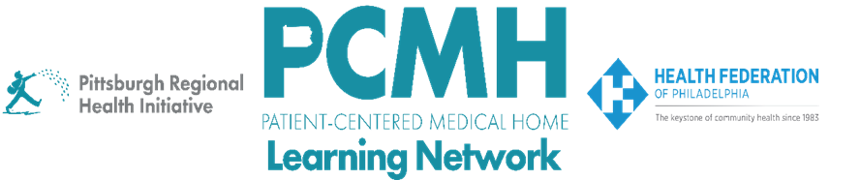

HealthChoices PCMH Learning Network
Statewide Session

Wednesday, June 25, 2025
8:30 a.m. to 3:30 p.m.

In-Person Only

Hilton Harrisburg
One North 2nd Street, Harrisburg, PA 17101

Learning Objectives:

- Describe the evolution of the HealthChoices PCMH and PCMH-PNC Programs from the perspectives of the PA DHS, MCOs, and PCMHs
- Describe what leads to success in the HealthChoices PCMH and PCMH-PNC Programs
- Describe examples of how PCMHs are implementing key interventions during the PCMH Learning Network’s 2025 Sprints
- Describe preliminary findings and progress from the mid-year sprint surveys
- Receive advice on how to breakthrough a current challenge with implementing a key intervention in one of the Sprints
- Describe examples of how PCMHs are using data to drive improvements
- List next steps and tactics to take back to your team to inform your quality improvement work in the HealthChoices PCMH and PCMH-PNC Programs

Agenda

8:30 a.m. to 8:45 a.m. – Welcome and Highlights from the Mid-Year PCMH Sprint Surveys – Robert Ferguson, MPH, Chief Policy Officer, Pittsburgh Regional Health Initiative (PRHI)

8:45 a.m. to 9:30 a.m. – HealthChoices PCMH and PCMH-PNC Programs: History, Evolution, and Future Directions – Gwendolyn B. Zander, Esq., Director, Bureau of Managed Care Operations, PA Department of Human Services’ Office of Medical Assistance Programs (PA DHS OMAP), & David Kelley, MD, MPA, Chief Medical Officer, PA DHS OMAP

9:30 a.m. to 9:40 a.m. – Break

9:40 a.m. to 10:40 a.m. – MCO Panel: HealthChoices PCMH Program Improvements –

- Lakshmi Reddy, MD, Senior Medical Director, Highmark Wholecare; and Stephen Perry, Director of VB Analytics & Operations, Highmark Wholecare
- Amy Buterbaugh, RN, BSN, Director HealthChoices Business Unit and Enhanced Member Services Unit, Geisinger Health Plan
- Valerie Van Buren, Director, Quality Improvement and Performance, Jefferson Health Plans
- Jessica Leibig, MA, LPC, Integrated Health Manager, Population Health Medical Services, AmeriHealth Caritas Pennsylvania and Keystone First
- Mike Kornhauser, MD, CMO, United Healthcare Community Plan of Pennsylvania
- Nick DeGregorio, MD, AVP Medicaid Services, UPMC Health Plan

10:40 a.m. to 11:00 a.m. – MCO and PCMH Appreciative Interviews: HealthChoices PCMH Accomplishments

11:00 a.m. to 11:10 a.m. – Transition to Breakout Rooms

11:10 a.m. to 11:50 p.m. – Breakout: Troika Consulting in PCMH Sprints

11:50 a.m. to 12:50 p.m. – Networking Lunch

12:50 p.m. to 1:00 p.m. – Transition to Breakout Rooms

1:00 p.m. to 2:00 p.m. – PCMH Sprint Knowledge Café Breakouts: Learning Across Sprints

- Post-Hospital Follow-up Breakout: Rachel Reis, BSN, RN-CCM, Director, Care Coordination, Jefferson Health

- Blood Pressure Control Breakout: Kim Allen, MSN, RN, CPHQ, Vice President and Chief Quality and Innovation Officer, Delaware Valley Community Health

- SDOH Interventions Breakout: Laurie Weidner, Director, Practice Transformation, AHN Risk & Value-Based Care, & Kristen Macey, Project Manager- Extended Care Teams, Primary Care Institute, Allegheny Health Network

- Well-Child & Well-Care Visits – Hetal Patel, MD, MPH, Family First Health

- Pediatric Nursing Care Breakout – Heather Goshorn, BSN, RN, Director of Enabling Services, Keystone Health

2:00 p.m. to 2:05 p.m. – Break

2:05 p.m. to 2:20 p.m. – Report Outs from the PCMH Sprint Knowledge Café Breakouts

2:20 p.m. to 3:00 p.m. – PCMH Spotlights: Using Data to Identify and Drive QI Work –

- Kathleen Barry, MS, Deputy Chief Operating Officer, The Wright Center for Community Health

- Maryann Salib, DO, MPH, Associate Medical Director of Community Health and Wellness, Population Health and Clinical Quality Assurance, Esperanza Health Center

- Laura Stack, DNP, MBA, RN, NE-BC, Ambulatory Nurse Executive, Tower Health

3:00 p.m. to 3:20 p.m. – Huddles and Report Outs

3:20 p.m. to 3:30 p.m. – Wrap-Up

