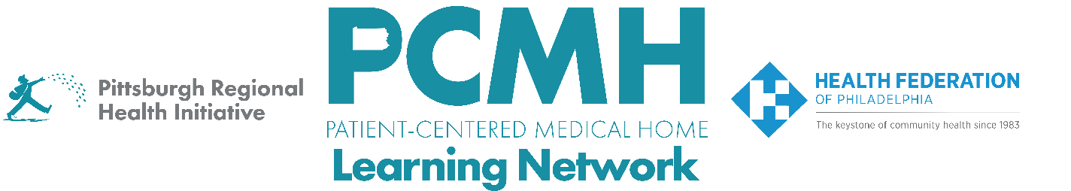
HealthChoices PCMH Learning Network
Quality Improvement for Blood Pressure Control and Asthma Medication Ratio
Wednesday, July 16 at 10:30 a.m. – 12:00 p.m. via Zoom

Register here: Session #3 – via Zoom

Learning Objectives:

- Describe progress in implementing key interventions.
- Describe practices that high performing providers utilize in their approach to controlling blood pressure.
- Collaborate on finding solutions to common challenges encountered in implementing key interventions to control blood pressure.

Agenda:

10:30 a.m. to 10:40 p.m. – Welcome & Overview – Suzanne Cohen, MPH, Senior Director of Population Health, The Health Federation of Philadelphia

10:40 a.m. to 11:10 a.m. Successfully Addressing Blood Pressure – Victor Lahnovych, MD, Medical Director, Keystone Rural Health Consortia, Inc., Nicole Hartung, LSW, Value-based Care Manager, Shellie Landers, CPC, Value-based Care Supervisor, Wayne Memorial Community Health Centers

11:10 a.m. to 11:50 a.m. Breakouts
Breakout rooms to discuss implementation progress and strategies to address challenges in controlling blood pressure.

11:50 a.m. to 12:00 p.m. – Next Steps & Evaluation

