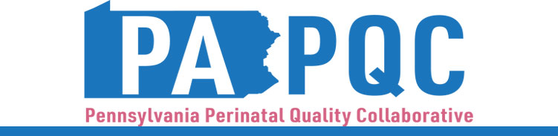

PA PQC Virtual Learning Session
Wednesday, October 1
11:00 a.m. to 12:00 p.m. ET
Virtual

Learning Objectives:
- Discuss how to gather patient feedback about UMWS education.
- Identify strategies other teams have implemented in their PDSA cycles for UMWS education.

Agenda:

11:00 a.m. to 11:05 a.m. – Welcome – Sara Nelis, RN, C-ONQS, CCE, PA PQC Program Manager, Jewish Healthcare Foundation

11:05 a.m. to 11:35 a.m. – Peer-to-Peer Discussion – Aasta Mehta, MD, MPP, PA PQC Advisory Group Co-Chair
- Share completed PDSA and plan for next PDSA cycle
- Troubleshoot remaining workflow issues

11:35 a.m. to 11:55 a.m. – Gathering Patient Feedback – …

11:55 a.m. to 12:00 p.m. – Wrap-up & Next Steps – Sara Nelis, RN, C-ONQS, CCE

