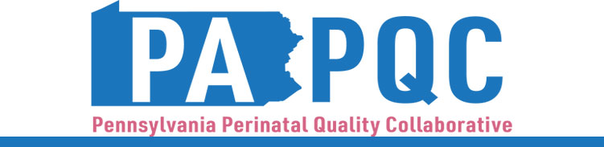

PA PQC Virtual Learning Session
Wednesday, October 15
11:00 a.m. to 12:00 p.m. ET
Virtual

Learning Objectives:
- Identify plan for assessment of the UMWS Sprint in your hospital.
- Discuss how to develop long-term plans to integrate UMWS handouts into standard discharge protocols.

Agenda:

11:00 a.m. to 11:05 a.m. – Welcome – Sara Nelis, RN, C-ONQS, CCE, PA PQC Program Manager, Jewish Healthcare Foundation

11:05 a.m. to 11:25 a.m. – Continued PDSA Cycles vs. Sustainment –

11:25 a.m. to 11:45 a.m. – Sprint Assessment –
- Measuring pre/post distribution rates for patient education on UMWS
- Gathering staff feedback

11:45 a.m. to 11:55 a.m. – Long-term Planning for Sustainment –

11:55 a.m. to 12:00 p.m. – Wrap-up & Next Steps – Sara Nelis, RN, C-ONQS, CCE

