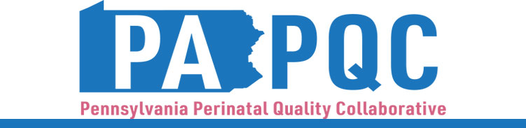

PA PQC Virtual Learning Session
Wednesday, September 17
11:00 a.m. to 12:00 p.m. ET
Virtual

Learning Objectives:
- Discuss successes and challenges gleaned from studying the “Plan” and “Do” elements of your hospital’s first PDSA for UMWS education.
- Identify ways to engage your staff in assessing the initial stages of UMWS patient education implementation.

Agenda:

11:00 a.m. to 11:05 a.m. – Welcome – Sara Nelis, RN, C-ONQS, CCE, PA PQC Program Manager, Jewish Healthcare Foundation

11:05 a.m. to 11:35 a.m. – Peer-to-Peer Discussion – Aasta Mehta, MD, MPP, PA PQC Advisory Group Co-Chair
- Studying the first Plan/Do from PDSA
- What has been going well?
- What barriers have you encountered?

11:35 a.m. to 11:45 a.m. – Conducting Staff Pulse Checks –

11:45 a.m. to 11:55 a.m. – Making Workflow Adjustments –

11:55 a.m. to 12:00 p.m. – Wrap-up & Next Steps – Sara Nelis, RN, C-ONQS, CCE

