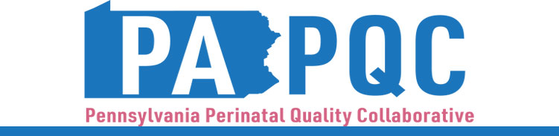

PA PQC Virtual Learning Session
Wednesday, September 3
11:00 a.m. to 12:00 p.m. ET
Virtual

Learning Objectives:
- Identify tools to facilitate small tests of change at your hospital regarding implementing Urgent Maternal Warning Signs (UMWS) education.
- Discuss ideas for addressing barriers to implementation of UMWS education.

Agenda:

11:00 a.m. to 11:05 a.m. – Welcome – Sara Nelis, RN, C-ONQS, CCE, PA PQC Program Manager, Jewish Healthcare Foundation

11:05 a.m. to 11:25 a.m. –
Share your pre-work for this session:
- Discussion about which tools did you use
- Documenting roles & responsibilities

11:25 a.m. to 11:40 a.m. – Moving from “Plan” to “Do” in a PDSA – Jennifer Condel, SCT(ASCP)MT, Manager, Lead QI Coach, Jewish Healthcare Foundation

11:40 a.m. to 11:55 a.m. – Peer-to-Peer Discussion – Aasta Mehta, MD, MPP, PA PQC Advisory Group Co-Chair
- Early lessons learned from hospitals who started implementing UMWS education before the print – ask sites who started doing the work if they would briefly present during the session
- Sharing plans from PDSA
- Addressing persistent concerns or barriers

11:55 a.m. to 12:00 p.m. – Wrap-up & Next Steps – Sara Nelis, RN, C-ONQS, CCE
- Helpful tips related to pre-work for next session

