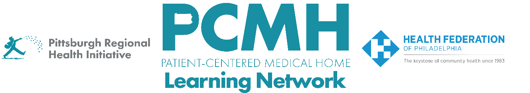
HealthChoices PCMH Learning Network
Post-Hospital Follow-up and Readmission Prevention Sprint
Thursday, August 14 at 9:00 a.m. – 10:30 a.m. via Zoom

Register here

Learning Objectives:

- Describe the role of risk stratification in effective post hospitalization follow-up.
- Describe progress in implementing risk stratification across participating practices.
- Collaborate on finding solutions to common obstacles encountered in implementing interventions.

Agenda:

9:00 a.m. to 9:30 a.m. – Welcome, Survey Feedback& Presentation on high level framing of the impact of risk-stratified hospital follow up and evidence for what works
- Share evidence-base for risk stratified hospital follow-up
- Present survey data results

9:30 a.m. to 10:15 a.m. – PCMH report outs on risk stratification approach
- What (if any) risk stratification algorithm is your PCMH using?
- How are you getting access to the data needed for accurate risk stratification.
- How is the risk level presented to your teams?
- How are you using risk stratification? i.e. who gets prioritized? Is there a cutoff for who gets follow-up? Are different team members/timeframes assigned based on risk?
- Are you able to measure results/impact on readmissions or other outcome measures based on risk?

10:15 a.m. to 10:30 a.m. – Wrap-up, Next Steps & Evaluation

