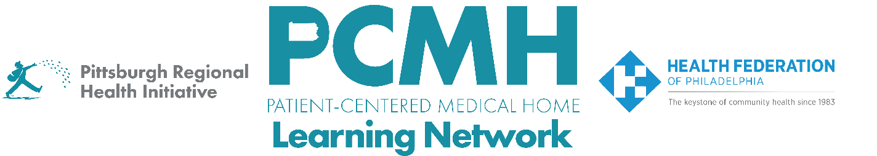

HealthChoices PCMH Learning Network
Well-Child and Adolescent Well-Care Visits Interventions Sprint
Session #3

Wednesday, August 27th at 9:30-11 a.m. via Zoom

Learning Objectives:
- Discuss preliminary findings and progress from the mid-year sprint surveys
- Describe how working with patient advisors can help PCMHs better understand why well-child and adolescent well-care visits are missed and develop effective outreach strategies

Agenda:

9:30 a.m. – 9:45 a.m. – Welcome & Discussion of Midyear Survey Data– Robert Ferguson, MPH, Chief Policy Officer, Pittsburgh Regional Health Initiative

9:45 a.m. to 10:30 a.m. – Working with Patient Advisors to Address Missed Well-Child and Adolescent Well-Care Visits – Renee Turchi, MD, MPH, FAAP, Medical Director, Center for Children and Youth with Special Healthcare Needs

10:30 a.m. to 10:55 a.m. – PCMH Peer-to-Peer Learning Discussion

10:55 a.m. to 11:00 a.m. – Next Steps & Wrap Up – Lisa Boyd, Program Specialist, PRHI

