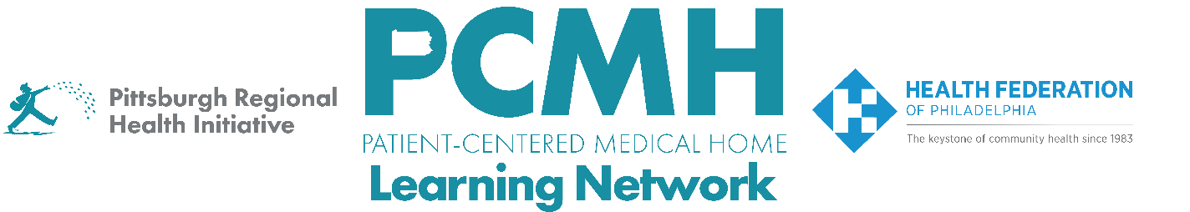

HealthChoices PCMH Learning Network
Social Determinants of Health (SDOH) Interventions
Sprint Session #3

Thursday, August 14th at 2:00 p.m. to 3:30 p.m. via Zoom

Learning Objectives:
- Discuss preliminary findings and progress from the mid-year sprint surveys
- Describe how a PCMH has implemented and sustained SDOH screening, documentation, and community health worker follow-up services

Agenda:

2:00 p.m. – 2:10 p.m. – Welcome & Discussion of Midyear Survey Data– Robert Ferguson, MPH, Chief Policy Officer, Pittsburgh Regional Health Initiative

2:10 p.m. – 3:00 p.m. – Family Practice Center’s Model and Workflows for SDOH Screening and Follow-Up – Allison Knepp, LPN, Population Health Nurse Manager, Family Practice Center, PC

3:00 p.m. to 3:25 p.m. – PCMH Peer-to-Peer Learning Discussion

3:25 p.m.– 3:30 p.m. – Next Steps & Wrap Up – Lisa Boyd, Program Specialist, Pittsburgh Regional Health Initiative

