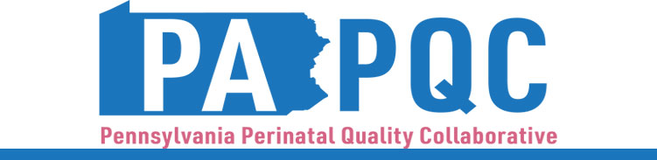

PA PQC Virtual Learning Session
Wednesday, September 17
11:00 a.m. to 12:00 p.m. ET
Virtual

Learning Objectives:
- Discuss successes and challenges gleaned from studying the “Plan” and “Do” elements of your hospital’s first PDSA for UMWS education.
- Identify ways to engage your staff in assessing the initial stages of UMWS patient education implementation.

Agenda:

11:00 a.m. to 11:05 a.m. – Welcome – Jennifer Condel, SCT(ASCP)MT, Senior Program Manager, Perinatal Health, Jewish Healthcare Foundation

11:05 a.m. to 11:10 a.m. – Summary of last sprint session – Kristen Brenneman, MSN, PA PQC QI Coach, Jewish Healthcare Foundation

11:10 a.m. to 11:15 a.m. – “Study” from PDSA – Jennifer Condel, SCT(ASCP)MT

11:15 a.m. to 11:20 a.m. – Conducting Staff Pulse Checks – Aasta Mehta, MD, MPP, PA PQC Advisory Group Co-Chair

11:20 a.m. to 11:55 a.m. – Peer-to-Peer Discussion – Aasta Mehta, MD, MPP
- Studying the first Plan/Do from PDSA
- What have you tried thus far?
- What has been going well?
- What barriers have you encountered?

11:55 a.m. to 12:00 p.m. – Wrap-up & Next Steps – Hadar Re’em, BA, Program Associate, Jewish Healthcare Foundation

