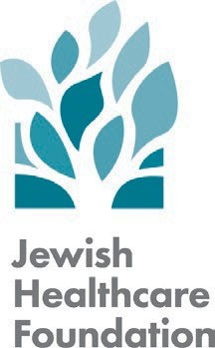
Death and Dying Series for Healthcare Professionals
October 23, 2025
3:30 – 5:30 pm

Zoom Link: https://us06web.zoom.us/j/83411293781?pwd=H3rqjDgdSytQjEfrdkEDTMoOqFm2tN.1 Meeting ID: 834 1129 3781
Passcode: 574722

Session Three:
Respecting Patient Choices in Serious Illness
Agenda |  | Objectives
3:30 pm | Reflections and Session Overview  Nancy Zionts, MBA  COO & Chief Program Officer Jewish Healthcare Foundation | - Describe the keys to effective POLST conversations.  - Demonstrate the techniques for having second POLST conversations  - Identify strategies to support a seriously ill patient who expresses a desire to hasten their death.  - Describe strategies for navigating ethical concerns in the setting of serious illness care.
3:35 pm | POLST Conversations Judith Black, MD, MHA Medical Advisor  Jewish Healthcare Foundation
3:55 pm | Ethics and Serious Illness  Rebekah Apple, MA, DHSC  Director, Master of Medical Management Program  Carnegie Mellon University
4:25 pm | Supporting Patients Requesting  Physician Aid in Dying  Heather Mikes, DO  Medical Director, Inpatient Palliative and Supportive Care  UPMC East and McKeesport Hospitals Clinical Instructor of Medicine  University of Pittsburgh School of Medicine
4:55 pm | Q&A with Panelists  - POLST Conversations – Judith Black, MD, MHA  - Death and Dignity – Heather Mikes, DO  - Ethics – Rebekah Apple, MA, DHSC
5:25 pm | Wrap-up and Preview Next Session  Nancy Zionts, MBA

