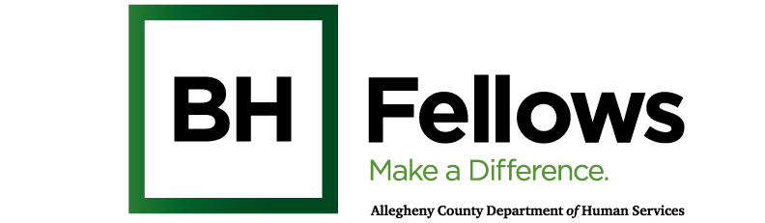
Cohorts 5, 6 and 7
October 9, 2025
9:00am – 12:00pm

Virtual Zoom:
Meeting ID:
Passcode:

Pre-session survey:
Requesting SW CEUs: 1.5 hrs
Time | Component | Content | Presenter/Facilitator
9:05 AM | Welcome & Introductions |  | Bridget McNamee, MID, Behavioral Health Project Manager, Jewish Healthcare Foundation
9:30 AM | Ethics | Ethical Guidelines and Principles for Behavioral Health Professionals | Ariel Clatty, PhD  Ethics Consultant, University of Pittsburgh  Rebekah Apple, MA, DHSc  Director, Master of Medical Management  Heinz College of Information Systems and Public Policy  Carnegie Mellon University
10:50 AM |  | Debrief, conclusion
11:00 AM |  | Mindfulness Activity
11:30 AM | Wrap-up and Reminders | Reflections and Take-aways: | Bridget
12:00 PM | Departure

