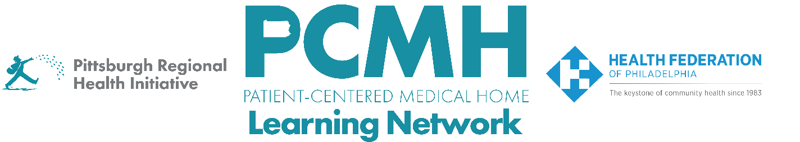

HealthChoices PCMH Learning Network
Well-Child and Adolescent Well-Care Visits Interventions Sprint
Session #4

Wednesday, October 29th at 10:00 - 11:00 a.m. via Zoom

Learning Objectives:
- Discuss the forecasted supply and guidelines for vaccines for children and adolescents
- Describe examples of how PCMHs have effectively integrated developmental screening and follow-up into their workflows

Agenda:

10:00 a.m. – 10:05 a.m. – Welcome– Robert Ferguson, MPH, Chief Policy Officer, Pittsburgh Regional Health Initiative

10:05 a.m. to 10:40 a.m. – Vaccination: Supply and Guidelines – Julie Myers, MPH, Public Health Program Manager, PA DOH Division of Vaccine Operations and Provider Services

10:40 a.m. to 10:55 a.m. – Discussion: Developmental Screening and Follow Up

10:55 a.m. to 11:00 a.m. – Next Steps & Wrap Up – Lisa Boyd, Program Specialist, PRHI

