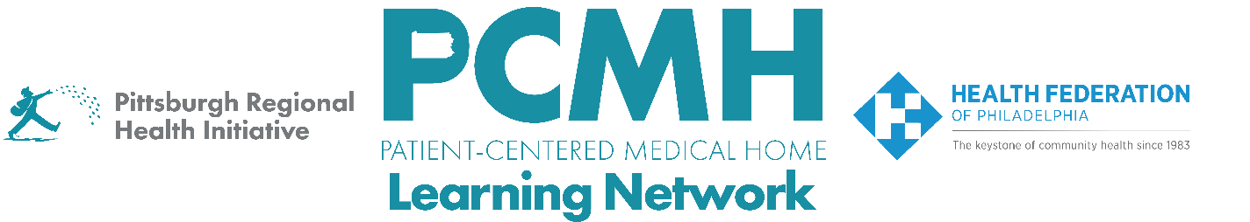

HealthChoices PCMH Learning Network
Pediatric Nursing Care (PNC) Team Sprint

Session #4 – Thursday, October 9th at 1-2:30 p.m. via Zoom

Learning Objectives:
- Describe the process for authorizing shift care services from the perspective of the PCMH
- Describe the process from the HHA perspective for ordering and authorizing shift care services
- Discuss opportunities for improvement with the processes for authorizing and ordering shift care services
- Describe available tools for ADL assessments

Agenda:

1:00 p.m. to 1:05 p.m. – Welcome – Robert Ferguson, MPH, Chief Policy Officer, Pittsburgh Regional Health Initiative (PRHI)

1:05 p.m. to 2:05 p.m. – Authorization of Shift Care Services: Current Workflow & Opportunities for Improvement from the Perspective of PCMHs, MCOs, and Home Health Agencies – Carol Frazer, MEd, LPC, Behavioral Health Specialist, PRHI

- How does this workflow compare with the workflow you are currently using?
- Are there any steps in the workflow that need to be changed or added from the perspective of PCMHs, MCOs, and HHAs?
- Are there any opportunities for improvement in the workflow that need to be added or refined?
- What opportunities for improvement need to be prioritized
- Who from your team will be part of working on improvements to the workflow?
- What are your next steps? How can PCMHs, HHAs, and MCOs collaborate on making improvements to achieve your next steps?

2:05 p.m. to 2:20 p.m. – ADL Assessment Tools – J. Ashenayi, MPH, Program Associate, PRHI

2:20 p.m. to 2:30 p.m. – Next Steps & Wrap Up – Lisa Boyd, Program Specialist, PRHI

