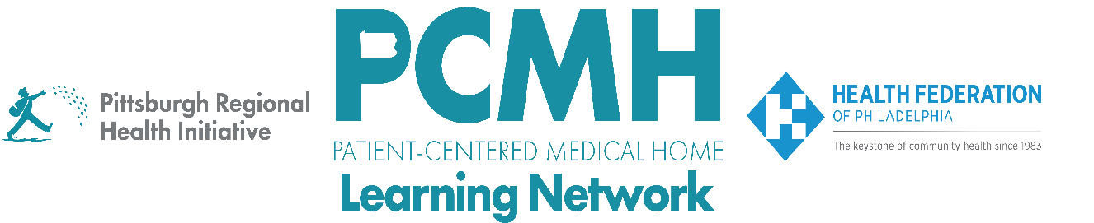

HealthChoices PCMH Learning Network
November Statewide Session
PCMH LN 2025 Wrap-Up
Thursday, November 13, 2025
9:30 a.m. – 11:00 a.m. via Zoom

Learning Objectives

- Describe key highlights and progress from the end-of-year sprint surveys
- Describe examples of how PCMHs have implemented a key intervention in each sprint.

Agenda

9:30 a.m. to 9:40 a.m. – Highlights from End of Sprint Survey Data – Robert Ferguson, MPH, Chief Policy Officer, Pittsburgh Regional Health Initiative

9:40 a.m. to 10:55 a.m. – PCMH Spotlights – 2025 Sprint Reflections

- Pediatric Nursing Care Sprint – will invite Keystone
- SDOH Interventions Sprint – will invite Guthrie
- Well-Child and Adolescent Well-Care Visits and Screenings Sprint
- Blood Pressure Control Sprint
- Post-Hospital Follow-up and Readmission Prevention Sprint

  - Why did you choose to prioritize the sprint?
  - What is the most impactful change you implemented?
  - What are you planning for next steps and/or sustainment?

10:55 a.m. to 11:00 a.m. – 2026 Next Steps & Wrap Up – Lisa Boyd, Program Specialist, Pittsburgh Regional Health Initiative

