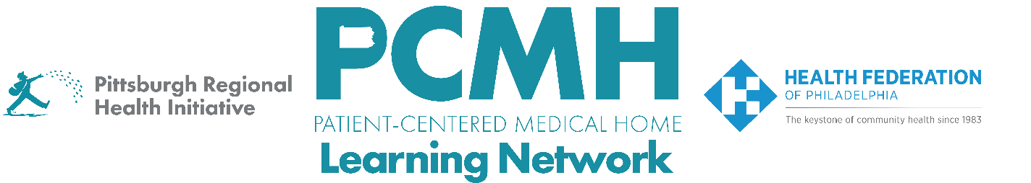
HealthChoices PCMH Learning Network
Post-Hospital Follow-up and Readmission Prevention Sprint
Thursday, October 16 at 10:30 a.m. – 12:00 p.m. via Zoom

Register: Here

Learning Objectives:

- Identify key interventions that are effective for PCMH practices in addressing post-hospital follow-up and preventing readmissions.
- Describe progress in incorporating key interventions across participating practices.
- Collaborate on finding solutions to common obstacles encountered in implementing interventions.

Agenda:

10:30 a.m. to 10:40 a.m. – Welcome & Recap – Suzanne Cohen, MPH, Senior Director of Population Health, The Health Federation of Philadelphia

- Focus on the overall plan for the 2025 sprint, including goals, the description of the measure, and the quality improvement framework

10:40 a.m. to 11:00 a.m. PCMH Spotlights: Scheduling Follow-Up Appointments
- Leticia Martez, Office Administrator, Jonathan B. Levyn, DOPC
- Andrew Eckert, DO, MPopH, FACOI, Medical Director, Population Health Management, Value-Based Care, and Clinical Call Services, UPMC Central PA

11:00 a.m. to 11:45 a.m. – PCMH Report Outs and Discussion, sharing:
- In choosing this sprint, what were your team’s goals for improving post-hospital follow-up?
- Which key intervention(s) made a difference?
- Describe how each relevant key intervention made a difference.
    - How did you decide which root causes to address?
    - Why did you choose this key intervention?
    - How did the process go?
    - What changes did you see as a result?
  - What are your next steps for improving follow-up and preventing readmissions?

11:45 a.m. to 12:00 p.m. – Sprint Process Feedback, Timeline, Next Steps & Evaluation

