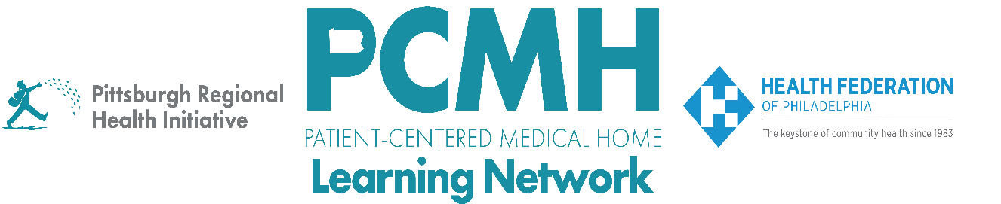

HealthChoices PCMH Learning Network
November Statewide Session
PCMH LN 2025 Wrap-Up
Thursday, November 13, 2025
9:30 a.m. – 11:00 a.m. via Zoom

Learning Objectives

- Describe key highlights and progress from the end-of-year sprint surveys
- Describe examples of how PCMHs have implemented a key intervention in each sprint

Agenda

9:30 a.m. to 9:35 a.m. – Welcome and Highlights from 2025 Sprints – Robert Ferguson, MPH, Chief Policy Officer, Pittsburgh Regional Health Initiative

9:35 a.m. to 10:55 a.m. – PCMH Spotlight

- SDOH Interventions Sprint – Becky Clouse, MS, Community Health Program Manager at Independence Health System and Angela Kypriotis, MSW, LCSW, Director, Extended Care Teams Allegheny Health Network

- Post-Hospital Follow-up and Readmission Prevention Sprint – Andrew Eckert, DO, MPopH, FACOI, Medical Director, Population Health Management, Value-Based Care, and Clinical Call Services, UPMC Central PA

- Well-Child and Adolescent Well-Care Visits and Screenings Sprint – Tina Ross, Sr. Director of Quality Hamilton Health Center, Inc.

- Blood Pressure Control Sprint – Paula Keenan, RN, CNO, Chief Nursing Officer, Scranton Primary Health Care Center, Inc.

- Pediatric Nursing Care Sprint – Heather Goshorn, BSN, RN, Director of Enabling Service, Keystone Health

10:55 a.m. to 11:00 a.m. – 2026 Learning Network Plans, Next Steps & Wrap Up – Robert Ferguson, PRHI

