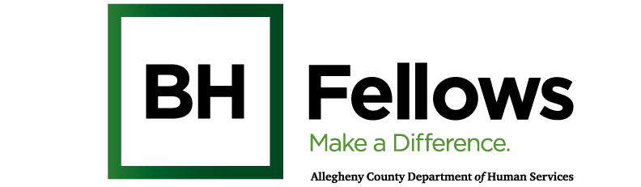

Cohort 8: Innov8rs
January 15, 2026
9:00am – 1:00pm

JHF Offices | 625 Liberty Ave, Ste. 2500, Pittsburgh, PA 15222

SW Credit Course Title: SAFETY IN THE WORKPLACE: APPLYING SITUATIONAL AWARENESS AND TRAUMA-INFORMED CARE CULTURE
Approved for: 2 credit hours for SW

Time | Component | Content | Presenter/Facilitator
8:30 AM | Check-in | Light breakfast refreshments
9:05 AM | Welcome & Introductions | Open with Sanctuary Model  Reflections | Bridget McNamee, MID, Behavioral Health Project Manager, Jewish Healthcare Foundation
9:30 AM | Didactic | Situational Awareness and Safety | Michael Bowersox, LPC,  Southwest PA AHEC (Area Health Education Center)
11:30 AM | Wellness Practices | Zen Tangle
12:00 PM | Wrap-up and Reminders | Next session:  - Cultural Humility, part 1: 2/26/2026, in person at JHF offices | Bridget McNamee
12:15 PM | Lunch
1:00 PM | Departure

CEU Survey: Session Survey:

