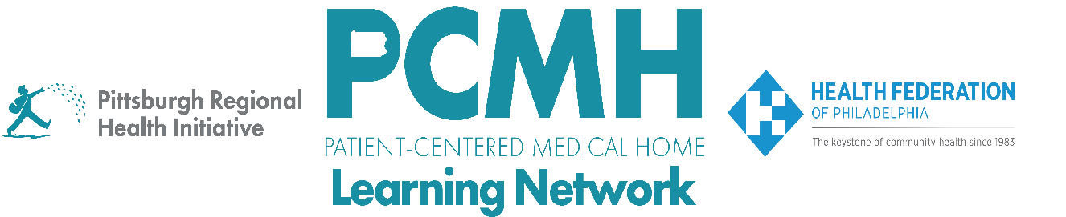

HealthChoices PCMH Learning Network
January Statewide Session
PCMH LN 2026 Kickoff
Tuesday, January 27
2:00 p.m. – 3:30 p.m.

Learning Objectives

- Describe the structure and expectations of the 2026 PCMH Learning Network sprints
- Discuss how PCMHs will use the QI Plans to track their progress over the course of the sprint
- Describe strategies to refine and enhance the planning stage of a PDSA cycle

Agenda:

2:00 p.m. to 2:10 p.m.–– Welcome – Robert Ferguson, MPH, Chief Policy Officer, Pittsburgh Regional Health Initiative

2:10 p.m. to 2:30 p.m. – Overview of the 2026 PCMH Learning Network Structure and Expectations – Robert Ferguson, MPH, Chief Policy Officer, Pittsburgh Regional Health Initiative; Suzanne Cohen, Senior Director of Population Health, The Health Federation of Philadelphia

2:30 p.m. to 2:40 p.m. – Related Statewide Initiatives

2:40 p.m. – 3:25 p.m. – Applying Implementation Science Frameworks and Principles to PDSA Planning

3:25 p.m.. to 3:30 p.m. – Wrap Up & Next Steps – Lisa Boyd, Program Specialist, Pittsburgh Regional Health Initiative

