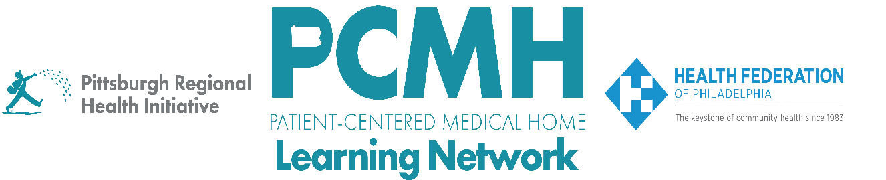

HealthChoices PCMH Learning Network
January Statewide Session
PCMH LN 2026 Kickoff
Tuesday, January 27
2:00 p.m. – 3:30 p.m.

Learning Objectives

- Describe the structure and expectations of the 2026 PCMH Learning Network sprints
- Discuss how PCMHs will use the QI Plans to track their progress over the course of the sprint
- Describe strategies to refine and enhance the Plan and Do stages of a PDSA cycle

Agenda:

2:00 p.m. to 2:10 p.m.–– Welcome – Robert Ferguson, MPH, Chief Policy Officer, Pittsburgh Regional Health Initiative

2:10 p.m. to 2:30 p.m. – Overview of the 2026 PCMH Learning Network Structure and Expectations – Laura Line, MS, Consultant, Health Federation of Philadelphia and Robert Ferguson, MPH, Chief Policy Officer, Pittsburgh Regional Health Initiative

2:30 p.m. to 2:40 p.m. – Discussion

2:40 p.m. – 3:10 p.m. – Guidance for the Plan Stages of PDSA - Robert Ferguson, MPH, Pittsburgh Regional Health Initiative and Suzanne Cohen, MPH, Senior Director of Population Health, Health Federation of Philadelphia

3:10 p.m. to 3:25 p.m. – Discussion

3:25 p.m.. to 3:30 p.m. – Wrap Up & Next Steps – Lisa Boyd, Program Specialist, Pittsburgh Regional Health Initiative

