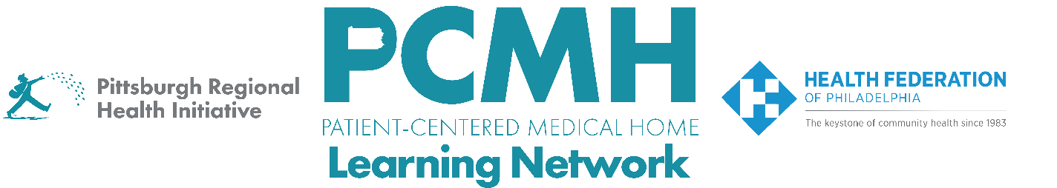

HealthChoices PCMH Learning Network
Perinatal Care in Family and Pediatric Offices Sprint
Session #1

Thursday, February 19, 2026 at 1:00 – 2:30 p.m. via Zoom

Learning Objectives:
- Describe evidence-based strategies for providing fourth trimester and interconception care to individuals at family medicine and pediatric well-visit appointments
- Discuss examples of PCMHs quality improvement projects for fourth trimester and interconception care
- Describe strategies to prepare for and enhance the “Do” stage of the PDSA cycle

Agenda:

1:00 p.m. to 1:05 p.m. – Welcome– Robert Ferguson, MPH, Chief Policy Officer, Pittsburgh Regional Health Initiative

1:05 p.m. to 1:45 p.m. – Evidence-Based Strategies for Fourth Trimester and Interconception Care in Family Practice and Pediatric Settings – Mario P. DeMarco, MD MPH, Associate Professor of Clinical Family Medicine, Perelman School of Medicine, University of Pennsylvania

1:45 p.m. to 2:15 p.m.– Facilitated Discussion & Peer to Peer Sharing

2:15 p.m. to 2:25 p.m. – Guidance for “Do” in PDSA Cycles

2:25 p.m. to 3:00 p.m. – Next Steps & Wrap Up – Lisa Boyd, Program Specialist, PRHI

