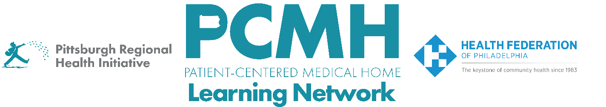

HealthChoices PCMH Learning Network
Comprehensive Diabetes Care and Health Equity Sprint
Tuesday, February 24 at 1:00 p.m. – 2:30 p.m. via Zoom

Register Here

Learning Objectives:

- Describe strategies that are effective in providing comprehensive diabetes care within primary care.
- Describe progress in planning quality improvement activities across participating PCMH practices.
- Identify potential approaches to implement quality improvement interventions.

Agenda:

1:00 p.m. to 1:20 p.m. – Welcome & Presentation on the plan for this 2026 sprint, the description of the measure, and a range of strategies for addressing diabetes care
- Describe HEDIS measures and HealthChoices PCMH Program requirement for Comprehensive Diabetes Care and Health Equity
- Describe menu of potential strategies
- Q&A

1:20 p.m. to 1:50 p.m. – – PCMH discussion of identified targets, sharing:
- What are your challenges and opportunities for impacting diabetes care?
- Which key interventions or other efforts resonate?
- What are your next steps?

1:50 p.m. to 2:10 p.m. – Demystifying Implementation Science - Meg Meador, MPH, C-PHI, CPHQ, Managing Director, Penn Medicine Nudge Unit, Center for Healthcare Transformation and Innovation, Penn Center for Health Incentives and Behavioral Health Economics

2:10 p.m. to 2:20 p.m. – Q&A

2:20 p.m. to 2:30 p.m. – Sprint Timeline, Next Steps & Evaluation

