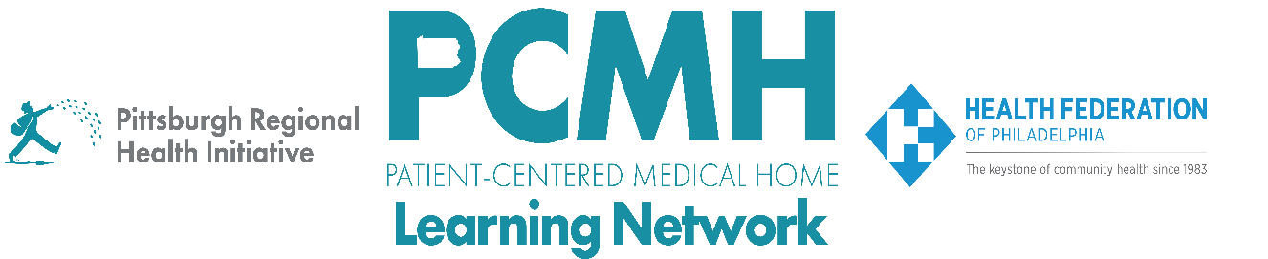

HealthChoices PCMH Learning Network
Pediatric Nursing Care Sprint
Session #1

Wednesday, March 18, 2026 at 1:00 – 2:30 p.m. via Zoom

Learning Objectives

- Discuss examples of PCMH Pediatric Nursing Care quality improvement projects
- Describe the processes related to authorizing and ordering shift care services
- Describe the goal and services of the Pediatric Complex Care Resource Centers (PCCRC)
- Discuss opportunities for how PCCRCs can collaborate with PCMH-PNCs

Agenda

1:00 p.m. to 1:03 p.m. – Welcome and Overview – Robert Ferguson, MPH, Chief Policy Officer, Pittsburgh Regional Health Initiative (PRHI)

1:03 p.m. to 1:13 p.m. – Overview of PCMH-PNC Program & FAQs About Shift Care Services and Authorization – Robert Ferguson, MPH, Chief Policy Officer, Pittsburgh Regional Health Initiative (PRHI)

1:13 p.m. to 1:50 p.m. – PCMH Discussion of PDSA Plans

1:50 p.m. to 2:00 p.m. – Overview of the Pediatric Complex Care Resource Centers (PCCRC): Goals, Structure, and Services – Nicole Harris, Executive Director, CHIP, Office of Medical Assistance Programs, PA Department of Human Services

2:00 p.m. to 2:28 p.m. – PCCRC Discussion with PCMH-PNCs and Regional PCCRC Representatives

2:28 p.m. to 2:30 p.m. – Wrap-up – Lisa Boyd, Program Associate, Pittsburgh Regional Health Initiative (PRHI)

