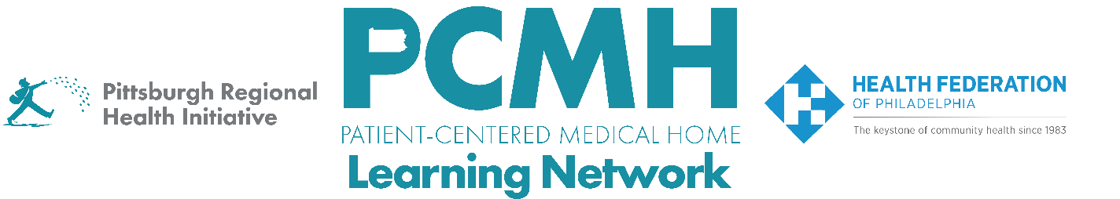

HealthChoices PCMH Learning Network
Behavioral Health Care Integration in Primary Care for Adults and Adolescents Sprint
Wednesday, March 11, 2026, at 9:00 a.m. – 10:30 a.m. via Zoom

Register Here

Learning Objectives:

- Describe strategies that are effective in integrating behavioral health care within primary care.
- Describe progress in planning quality improvement activities across participating PCMH practices.
- Identify potential approaches to implement quality improvement interventions.

Agenda:

9:00 a.m. to 9:20 a.m. – Welcome & Presentation on the plan for this 2026 sprint, the description of the range of approaches and metrics for integrating behavioral health care
- Summary of goal areas for PCMHs
- Q&A

9:20 a.m. to 9:50 a.m. – Demystifying Implementation Science - Meg Meador, MPH, C-PHI, CPHQ, Managing Director, Penn Medicine Nudge Unit, Center for Healthcare Transformation and Innovation, Penn Center for Health Incentives and Behavioral Health Economics

9:50 a.m. to 10:20 a.m. – PCMH discussion of identified targets, sharing:
- What are your challenges and opportunities for integrating behavioral health care?
- Which key interventions or other efforts resonate?
- What are your next steps?

10:20 a.m. to 10:30 a.m. – Sprint Timeline, Next Steps & Evaluation

