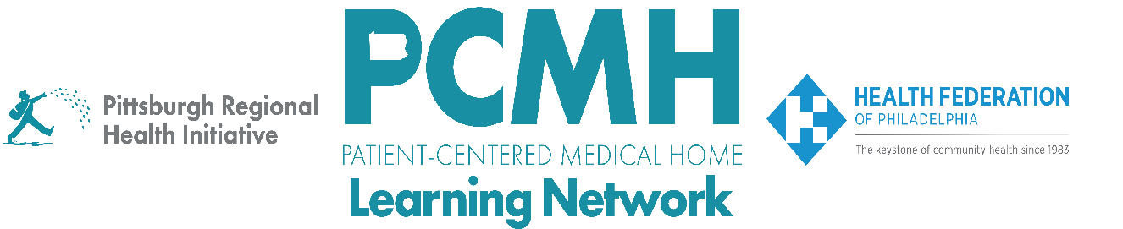

HealthChoices PCMH Learning Network
Pediatric Nursing Care Sprint
Session #1

Wednesday, March 18, 2026 at 1:00 – 2:30 p.m. via Zoom

Learning Objectives

- Discuss examples of PCMH Pediatric Nursing Care quality improvement projects
- Describe the goal and services of the Pediatric Complex Care Resource Centers (PCCRC)
- Discuss opportunities for how PCCRCs can collaborate with PCMH-PNCs

Agenda

1:00 p.m. to 1:10 p.m. (10 min.) – Welcome and Overview of PCMH-PNC Program – Robert Ferguson, MPH, Chief Policy Officer, Pittsburgh Regional Health Initiative (PRHI)

1:10 p.m. to 1:50 p.m. (35 min.) – PCMH Discussion of PDSA Plans

1:50 p.m. to 2:05 p.m. (15 min.) – Overview of the Pediatric Complex Care Resource Centers (PCCRCs): Goals, Structure, and Services – Nicole Harris, Executive Director, CHIP, Office of Medical Assistance Programs, PA Department of Human Services, and Heidi Arva, Clinical Consultant, PA DHS Office of Developmental Programs

2:05 p.m. to 2:28 p.m. (23 min.) – Identifying Connections between PCMH-PNCs and PCCRCs – Facilitated by Robert Ferguson

2:28 p.m. to 2:30 p.m. – Wrap-up – Lisa Boyd, Program Specialist, Pittsburgh Regional Health Initiative (PRHI)

Resources: PCCRC website https://www.pa.gov/agencies/dhs/resources/medicaid/pediatric-complex-care-resource-centers

