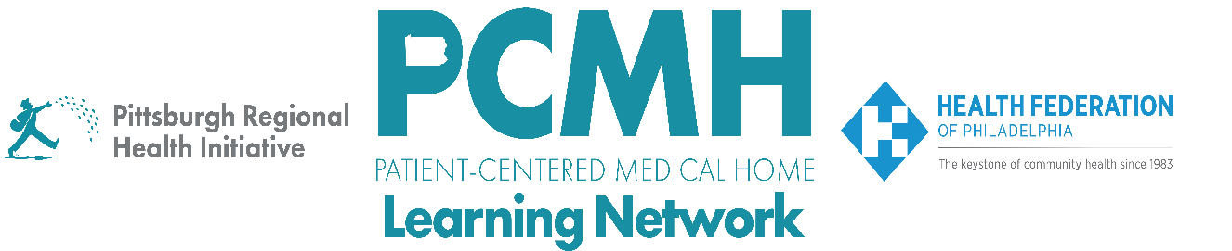

HealthChoices PCMH Learning Network
Supplemental Statewide Session
New Physical HealthChoices Community Health Worker (CHW) Policies
Thursday, March 26, 2026
2:00 p.m. to 3:00 p.m. via Zoom

Learning Objectives

- Increase awareness and understanding of the new Physical HealthChoices’ CHW policies
- Receive general guidance to inform PCMH next steps

Agenda

2:00 p.m. to 2:05 p.m. – Welcome – Robert Ferguson, MPH, Chief Policy Officer, Pittsburgh Regional Health Initiative

2:05 p.m. to 2:35 p.m. – Review of the New Physical HealthChoices Community Health Worker (CHW) Policies – Gwen Zander, Esq., Director, Bureau of Managed Care Operations, Department of Human Services, Office of Medical Assistance Programs

2:35 p.m. to 2:55 p.m. – Discussion – Facilitated by Robert Ferguson

2:55 p.m. to 3:00 p.m. – Wrap Up – Lisa Boyd, Program Specialist, Pittsburgh Regional Health Initiative

