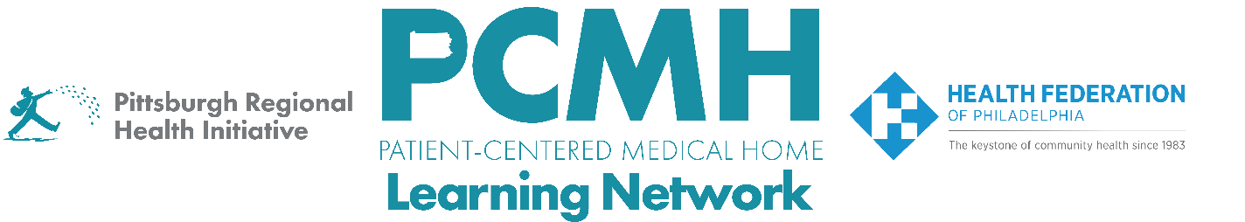

HealthChoices PCMH Learning Network
Behavioral Health Integration for Adolescents and Adults in Primary Care Sprint
Tuesday, April 21 at 1:00 p.m. – 2:30 p.m. via Zoom

Register Here

Learning Objectives:

- Describe strategies that are effective in optimizing referral to and engagement with integrated behavioral health teams within primary care.
- Describe progress in planning quality improvement activities across participating PCMH practices.
- Identify potential approaches to implement quality improvement interventions.

Agenda:

1:00 p.m. to 1:10 p.m. – Welcome

1:10 p.m. to 1:35: p.m. – Community Health: Best Practices and Lessons Learned for Integrated Behavioral Health - Joel McIntosh, LCSW, Director of Behavioral Health, Delaware Valley

1:35 p.m. to 2:20 p.m. – Sprint session participants share PDSAs

- Describe the PDSA cycle goal.
- Describe the specific intervention/approach and the steps the PCMH is taking to implement it.
- How will you know this intervention/approach has taken hold? (in other words, what changes do you expect to see and how are you measuring these?)

2:20 p.m. to 2:30 p.m. – Sprint Timeline, Next Steps & Evaluation

