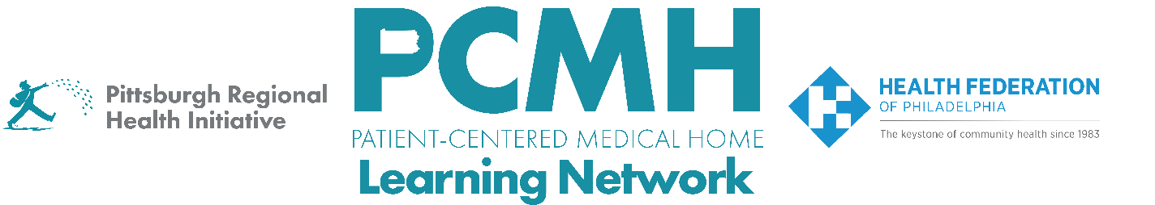
HealthChoices PCMH Learning Network
Comprehensive Diabetes Care and Health Equity Sprint
Thursday, April 9 at 9:00 a.m. – 10:30 a.m. via Zoom

Register here

Learning Objectives:

- Describe strategies that are effective in providing comprehensive diabetes care within primary care.
- Describe progress in planning quality improvement activities across participating PCMH practices.
- Identify potential approaches to implement quality improvement interventions.

Agenda:

9:00 a.m. to 9:15 a.m. – Welcome & Presentation -- Suzanne Cohen, MPH, Senior Director of Population Health, Health Federation of Philadelphia

9:15 a.m. to 9:45 a.m. – – Panel Discussion: Care Team Roles Supporting Diabetes Care
Facilitator: Suzanne Cohen, MPH, Senior Director of Population Health, Health Federation of Philadelphia
Panelists include:
- Ashley Boschi, LPN, CCHW, Nurse Care Manager, River Valley Health
- Melissa Egan, BSN, RN, BSPH, Quality and Risk Manager, East Liberty Family Health Care Center
- Shelby Ezzo, Pay for Value Manager, and Briana Ondic, Certified Medical Assistant, Primary Health Network
Questions include:
- What does your care team look like for supporting diabetes care?
- How do the different care team members work to support patients with diabetes?
- How does this care team approach impact patient engagement in their own diabetes care?
- Are there other care team members that could be added to increase patient engagement? What, if any, are the barriers to including these roles on the team?
9:45 a.m. to 10:15 a.m. – Breakouts: Review PDSAs with sprint session participants
- Reducing A1(c) <9
- Related needs: Behavioral Health, Retinopathy and Kidney testing

10:15 a.m. to 10:30 a.m. – Sprint Timeline, Next Steps & Evaluation

