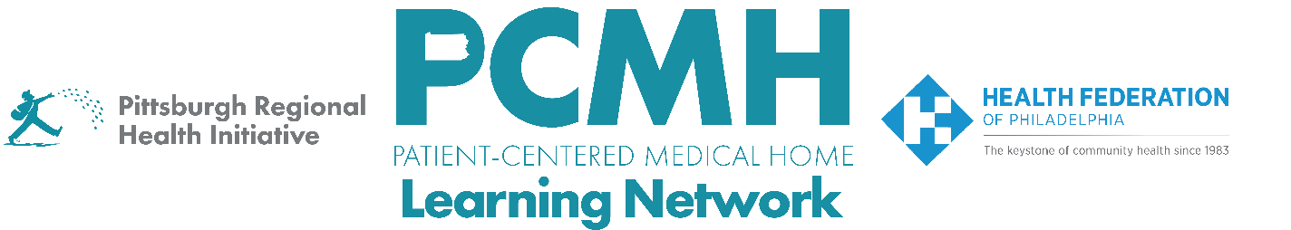

HealthChoices PCMH Learning Network
Perinatal Care in Family and Pediatric Offices Sprint
Session #2

Wednesday, April 1st from 9:00 to 10:30 a.m. via Zoom

Learning Objectives:
- Describe strategies for family and patient engagement and education on vaccination in pediatric settings
- Discuss progress in PCMH quality improvement projects for improving perinatal care in family and pediatric offices
- Describe strategies to prepare for and implement the Do and Study stages of the PDSA cycle

Agenda:

9:00 a.m. to 9:05 a.m. – Welcome – Robert Ferguson, MPH, Chief Policy Officer, Pittsburgh Regional Health Initiative

9:05 a.m. to 9:45 a.m. – Family and Patient Engagement and Education Strategies for Vaccination – Alicia Hartung, DO, IBCLC and Lisa G. Zur, MPH, Health Innovations Program Manager, Kids Plus Pediatrics

9:45 a.m. to 10:25 a.m. – Facilitated Discussion, Peer-to-Peer Learning & Guidance for Next Steps in PDSA Cycle

10:25 a.m. to 10:30 a.m. – Next Steps & Wrap Up – Lisa Boyd, Program Specialist, PRHI

