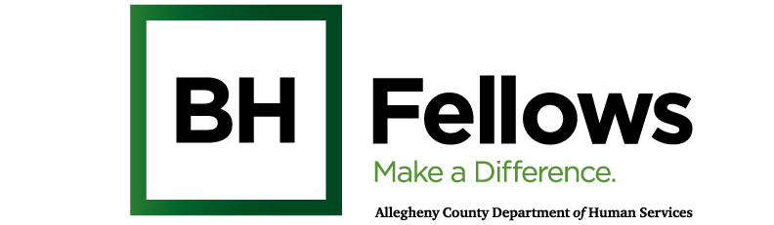

Cohort 6: The Six Pack & Cohort 7: The Zesty Fellows
Grief, Loss, & Suicide
July 23, 2026
9:00am – 5:00pm

JHF, 25th Floor | 625 Liberty Ave, Ste. 2500, Pittsburgh, PA 15222
SW CEU Credit Hours: 1 hour

Time | Component | Content | Presenter/Facilitator
8:30 AM | Check-in | Light breakfast refreshments
9:05 AM | Welcome & Introductions | Review Day’s Agenda  Sanctuary Model Check-In | Bridget McNamee, MID, Behavioral Health Project Manager, Jewish Healthcare Foundation
9:30 AM | Didactic | Navigating Grief and Suicide as a Behavioral Health Provider  *requesting 1 hr SW CEU for Suicide portion of presentation | Elizabeth Schandelmeier, LCSW, APHSW-C, FT
11:00 AM | Break
11:10 AM | Community Provider Panel | Rev. Richard Freeman, Sr., MSPC  Manager and Chaplain, Pastoral Care Children’s Hospital of Pittsburgh of UPMC | Second Panelist
12:15 PM | Lunch
1:15 PM |  | Walk to Highmark Caring Place
1:30 PM | Community Spotlight | Highmark Caring Place | Denija Ducasse
3:30 PM | Debrief  Wrap-up and Reminders | - Take aways & Reflection  - Next session:  - Cohort 6: Fellowship Reflection (9/24/2026)  - Cohort 7: Healing & Recovery (9/17/2026) | Bridget McNamee
3:40 PM | Departure
SURVEYS
CEU Survey

