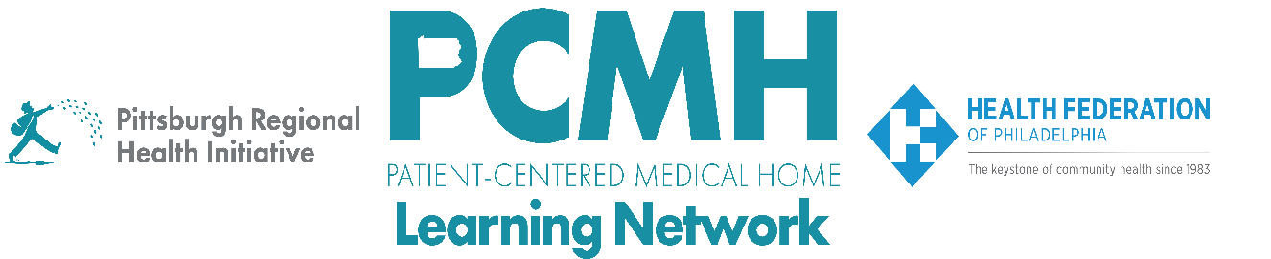

HealthChoices PCMH Learning Network
Pediatric Nursing Care Sprint
Session #2

Tuesday, May 5, 2026 at 9:00 – 10:30 a.m. via Zoom

Learning Objectives

- Discuss principles and tools for creating and sustaining standard work for new team roles
- Describe examples of how PCMHs are defining roles and standard work for PCMH-PNC Case Managers

Agenda

9:00 a.m. to 9:05 a.m. (5 min.) – Welcome & New Shift Care Resource – Robert Ferguson, MPH, Chief Policy Officer, Pittsburgh Regional Health Initiative (PRHI)

9:05 a.m. to 9:25 a.m. (20 min.) – Creating Standard Work for New Team Roles – Robert Ferguson, PRHI

9:25 a.m. to 10:25 a.m. (60 min.) – PCMH Discussion of Case Manager Team Role and PDSA Plans
Discussion Questions:
- How have you defined your Case Manager role? What has worked well to standardize, train, and onboard this role in your PCMH?
- Describe how your Case Manager interfaces with the Multidisciplinary Care Team. Does the Case Manager convene the team or have a leadership role?
- Briefly describe the current status of your PDSA, including any successes, barriers or anticipated barriers, questions for your peers, and next steps.

10:25 a.m. to 10:30 a.m. (5 min.) – Wrap-up – Lisa Boyd, Program Specialist, Pittsburgh Regional Health Initiative (PRHI)

