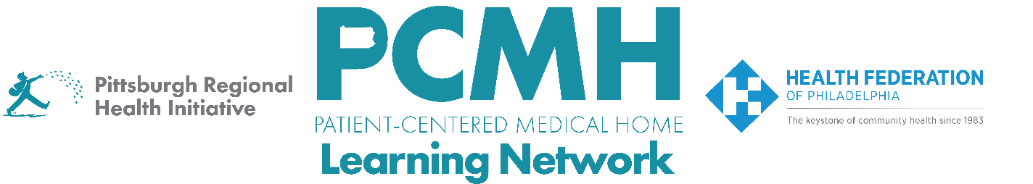
HealthChoices PCMH Learning Network
Comprehensive Diabetes Care and Health Equity Sprint
Tuesday, June 16 at 1:00 p.m. – 2:30 p.m. via Zoom

Register Here

Learning Objectives:

- Describe strategies that are effective in providing comprehensive diabetes care within primary care.
- Describe progress in planning quality improvement activities across participating PCMH practices.
- Identify potential approaches to implement quality improvement interventions.

Agenda:

1:00 p.m. to 1:15 p.m. – Welcome & Presentation on the transition to the second PDSA cycle

1:15 p.m. to 1:45 p.m. – PCMH Sharing of Challenges and Potential Support
- Review pre-survey results on challenges and potential PCMH Learning Network support
- Discussion

1:45 p.m. – 2:15pm – PCMH Panel Discussion: Moving from PDSA Cycle 1 to 2
Representatives include:
- Whitney Gregori, BSN-RN, Manager, Value-Based Reimbursement, Guthrie Medical Group
- Jaime Bailey, RN, MSN, CCM, Supervisor CMI PCMH, UPMC Health Plan
Prompts:
- Please describe your PCMH's goal and intervention(s) for the first PDSA cycle.
- Recognizing that this process is continuing, what are your preliminary findings to date? (Please share any quantitative results as well, if you have them.)
- Describe what your team has learned in this process and how it is driving your next steps.
- How will you apply what you have learned to date in forming this next PDSA cycle? What is your new/revised goal?

2:15 p.m. to 2:30 p.m. – Sprint Timeline, Next Steps & Evaluation

