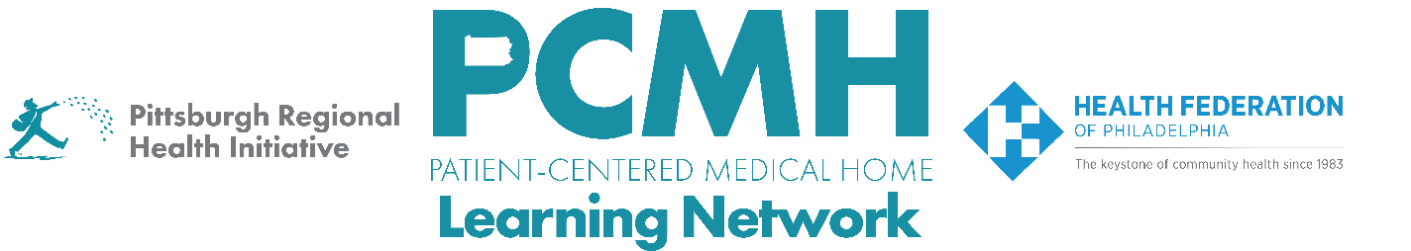

HealthChoices PCMH Learning Network
Perinatal Care in Family and Pediatric Offices Sprint
Session #3

Tuesday, June 23rd from 1:00 – 2:30 p.m. via Zoom

Learning Objectives:
- Describe strategies for maternal mental health screening and referrals in pediatric and family practice settings
- Discuss progress in PCMH quality improvement projects for improving perinatal care in family and pediatric offices
- Describe strategies to implement the second PDSA sprint cycle

Agenda:

1:00 p.m. to 1:05 p.m.. – Welcome – Robert Ferguson, MPH, Chief Policy Officer, Pittsburgh Regional Health Initiative

1:05 pm. To 1;45 p.m. – Maternal Mental Health Screening and Referral Strategies for Pediatric and Family Practice Settings - Brianna K. Moyer, MD, LG Health Physicians Family and Maternity Medicine and Sarah H. Jones, MD, University of Mississippi Medical Center

1:45 p.m. to 2:25 p.m. – Facilitated Discussion, Peer-to-Peer Learning & Guidance for Next Steps in PDSA Cycle

- Briefly describe your PCMH's goal, intervention(s), and findings for the first PDSA cycle.
- How have your early findings influenced the focus of your second PDSA cycle?
- As you move into the second PDSA sprint, what implementation challenges are you anticipating, and what strategies are you considering to address them?
- Thinking about the screening and referral strategies discussed by today's speakers, what ideas or approaches are most relevant to your practice's next phase of improvement work?

2:25 p.m. to 2:30 p.m. – Next Steps & Wrap Up – Lisa Boyd, Program Specialist, PRHI

