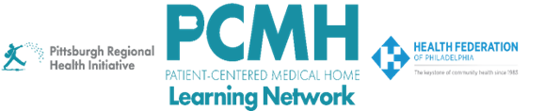

HealthChoices PCMH Learning Network
July Supplemental Learning Session
HIV Screening, Prevention, and Treatment

Wednesday, July 29, 2026
9:00 to 10:00 a.m. via Zoom

Learning Objectives

- Discuss current approaches to HIV screening, prevention, and treatment in primary care settings, including opportunities to improve access and engagement across patient populations
- Describe emerging strategies for HIV prevention and treatment, including long-acting injectables
- Identify the roles of interdisciplinary care team members, including community health workers, in supporting HIV screening, linkage to care, treatment adherence, and prevention services
- Apply lessons from clinical cases to address common challenges and opportunities related to HIV screening, prevention, and care in primary care practice

Agenda

9:00 a.m. to 9:05 a.m. – Welcome and Overview – Robert Ferguson, MPH, Chief Policy Officer, Pittsburgh Regional Health Initiative (PRHI)

9:05 a.m. to 9:45 a.m. – HIV Screening, Prevention, and Treatment – Ken S. Ho, MD, MPH, Associate Professor of Medicine, University of Pittsburgh Medical Center; Medical Director, Pitt Men's Study, Multicenter AIDS Cohort Study.

9:45 a.m. – 9:55 a.m. – Q&A – moderated by Robert Ferguson, MPH, Chief Policy Officer, Pittsburgh Regional Health Initiative (PRHI)

9:55 a.m. to 10:00 a.m. – Wrap-Up – Robert Ferguson, MPH, Chief Policy Officer, Pittsburgh Regional Health Initiative (PRHI)

