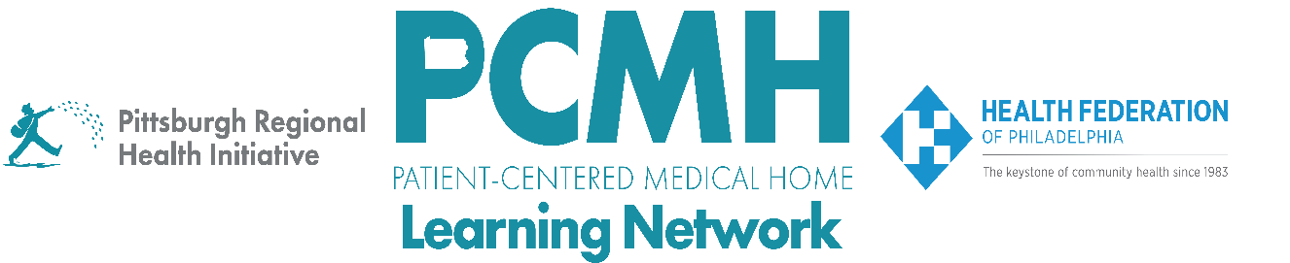

HealthChoices PCMH Learning Network
Statewide Midyear Session
PCMH LN 2026
Tuesday, June 2, 2026
9:00 a.m. – 10:30 a.m. via Zoom

Learning Objectives

- Discuss examples of how PCMHs have implemented a PDSA cycle in each sprint
- Describe strategies for applying findings from the Study and Act stages to develop iterative PDSA cycles

Agenda

9:00 a.m. to 9:05 a.m. – Welcome– Robert Ferguson, MPH, Chief Policy Officer, Pittsburgh Regional Health Initiative

9:05 a.m. to 9:25 a.m. – Guidance for the Developing Iterative PDSA Cycles - Suzanne Cohen, MPH, Senior Director of Population Health, Health Federation of Philadelphia

9:25 a.m. to 10:25 a.m. – PCMH Spotlights:

- Comprehensive Diabetes Care & Health Equity – Cynthia E. Wright-Kent, MBA, Director of Managed Care/Population Health, Greater Philadelphia Health Action, Inc.

- Perinatal Care in Family and Pediatric Offices – Alicia Hartung, DO, IBCLC and Lisa G. Zur, MPH, Health Innovations Program Manager, Kids Plus Pediatrics

- Behavioral Health Integration for Adolescents and Adults in Primary Care – Liz Leen, LCSW, Behavioral Health Program Manager, Family First Health

- Pediatric Nursing Care Sprint – Kayla Whalen, RN, Nurse Care Coordinator, UPMC Children’s Community Pediatrics

10:25 a.m. to 10:30 a.m. – Next Steps & Wrap Up – Lisa Boyd, Program Specialist, PRHI

