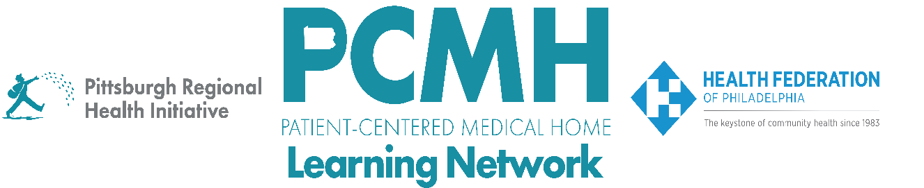

HealthChoices PCMH Learning Network
June Supplemental Statewide Session
Sepsis in Primary Care Settings

Thursday, June 4, 2026
5:00 to 6:00 p.m. via Zoom

Learning Objectives

- Discuss the role of risk stratification in outpatient early identification and timely treatment of sepsis
- Describe short- and long-term considerations and strategies for effective care of sepsis survivors in primary care settings
- Identify barriers to information transfer during care transitions for sepsis survivors and strategies for improvement
- Describe the use case for ICD-10 code Z51.A 'Encounter for Sepsis Aftercare

Agenda

5:00 p.m. to 5:05 p.m. – Welcome and Overview – Robert Ferguson, MPH, Chief Policy Officer, Pittsburgh Regional Health Initiative (PRHI)

5:05 p.m. to 5:45 p.m. – Sepsis in Primary Care Settings – Kathryn Bowles PhD, RN, FAAN, FACMI, Professor of Nursing, Van Ameringen Chair in Nursing Excellence, University of Pennsylvania School of Nursing, VP and Director of the Center for Home Care Policy & Research VNS Health

Dr. Bowles will discuss considerations for primary care providers in providing post-discharge care to patients with sepsis, including strategies for effective patient education, guidance on implementing the new sepsis aftercare code, and the value of timely home health and outpatient care. Dr. Bowles is a professor at the University of Pennsylvania School of Nursing and a leader in the development of a new Z-Code for sepsis aftercare.

5:45 – 5:55 pm – Q&A – moderated by Robert Ferguson, MPH, Chief Policy Officer, Pittsburgh Regional Health Initiative (PRHI)

5:55 p.m. to 6:00 p.m. – Wrap-Up – Robert Ferguson, MPH, Chief Policy Officer, Pittsburgh Regional Health Initiative (PRHI)

