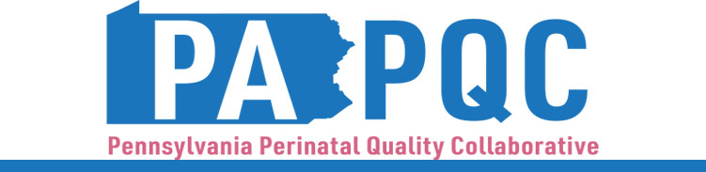

PA PQC Virtual Learning Session
Incorporating Patient Voice
Wednesday, July 8
11:00 a.m. to 12:00 p.m. ET
Virtual

Learning Objectives:

- Describe approaches for creating meaningful patient partnership opportunities to improve perinatal care
- Discuss examples of how to incorporate patient lived experience into initiative-specific quality improvement work

Agenda:

11:00 a.m. to 11:03 a.m. – Welcome – Jennifer Condel, SCT(ASCP)MT, Senior Program Manager, Perinatal Health, Jewish Healthcare Foundation

11:03 a.m. to 11:23 a.m. – Patient Family Partners Program Overview – Jennifer Mikenas, Program Manager, MoMMAs Voices, Preeclampsia Foundation

11:23 a.m. to 11:58 a.m. – Lived Experience Panel & Discussion – Michelle Kavouras, CDCS, CADC, NCPRSS, RCPF, and Katie Spencer, Maternal Mental Health Advocate

11:55 a.m. to 12:00 p.m. – Wrap-up & Next Steps

