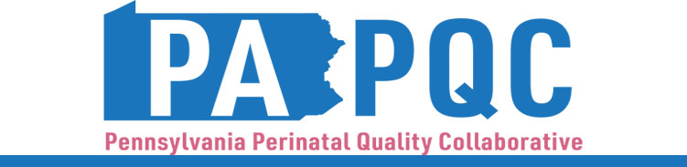

PA PQC Virtual Learning Session
Plans of Safe Care
Wednesday, August 12
11:00 a.m. to 12:00 p.m. ET
Virtual

Learning Objectives:

- Describe an example of how a hospital has improved discharge processes and engaging with families for Plans of Safe Care
- Describe the role of the Plans of Safe Care Coordinator and county agency in engaging and supporting families with Plans of Safe Care

Agenda:

11:00 a.m. to 11:03 a.m. – Welcome – Jennifer Condel, SCT(ASCP)MT, Senior Program Manager, Perinatal Health, Jewish Healthcare Foundation

11:03 a.m. to 11:18 a.m. – Plans of Safe Care at UPMC Northwest – Samantha Hartle, BSN, RN, CARN, FIAAN, CRS, Outpatient RN Coordinator, UPMC Northwest

11:18 a.m. to 11:33 a.m. – Venango County – Plans of Safe Care Coordination –Michelle Sanchez, POSC Coordinator and Justin Heffernan, SCA Administrator, Venango County Human Services

11:33 a.m. to 11:48 a.m. – Plans of Safe Care: Patient Perspective – Speaker to Be Confirmed

11:48 a.m. to 11:58 a.m. – Facilitated Discussion

11:58 a.m. to 12:00 p.m. – Wrap-up & Next Steps – Lisa Boyd, Program Specialist, Jewish Healthcare Foundation

