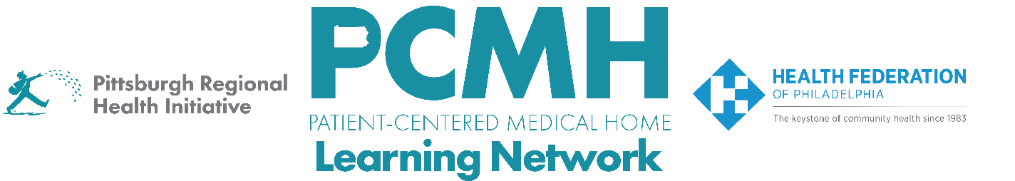

HealthChoices PCMH Learning Network
Behavioral Health Integration Sprint
Thursday, July 9 at 9:00 a.m. – 10:30 a.m. via Zoom

Register Here

Learning Objectives:

- Describe strategies that are effective in integrating behavioral health within primary care.
- Describe progress in planning quality improvement activities across participating PCMH practices.
- Identify potential approaches to implement quality improvement interventions.

Agenda:

9:00 a.m. to 9:15 a.m. – Welcome & Presentation on the transition to the second PDSA cycle

9:15 a.m. to 9:45 p.m. – PCMH Sharing of Challenges and Potential Support
- Review pre-survey results on challenges and potential PCMH Learning Network support
- Discussion

9:45 p.m. – 10:15am – PCMH Panel Discussion: Moving from PDSA Cycle 1 to 2
- PCMH Representatives from: Berks Community Health Center
Prompts:
- Please describe your PCMH's goal and intervention(s) for the first PDSA cycle.
- Recognizing that this process is continuing, what are your preliminary findings to date? (Please share any quantitative results as well, if you have them.)
- Describe what your team has learned in this process and how it is driving your next steps.
- How will you apply what you have learned to date in forming this next PDSA cycle? What is your new/revised goal?

10:15 a.m. to 10:30 a.m. – Sprint Timeline, Next Steps & Evaluation

