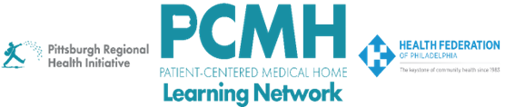

HealthChoices PCMH Learning Network
Pediatric Nursing Care Sprint
Session #3

Tuesday, July 14, 2026 at 1:00 – 2:30 p.m. via Zoom

Learning Objectives

- Describe an example of how PCMH PNCs can improve the patient and family transition from pediatric to adult care
- Discuss how PCMH PNC teams can use tools like Gemba Walks and the RACI matrix to define roles and standard work for PCMH-PNC Case Managers
- Discuss progress in PCMH PNC quality improvement projects
- Describe strategies to implement the second PDSA sprint cycle

Agenda

1:00 p.m. to 1:05 p.m. – Welcome – Robert Ferguson, MPH, Chief Policy Officer, Pittsburgh Regional Health Initiative (PRHI)

1:05 p.m. to 1:45 p.m. – PCMH Spotlights – Luann Hess, RN, Senior Clinical Director, and Jennifer Aguilar, MSN, RN, Pediatric Nurse Navigator, WellSpan Community Health Center; and Joan Thode, MD, Pediatrician, Lancaster General Health Physicians Roseville Pediatrics
1:45 p.m. to 2:25 p.m. – Facilitated Discussion, Peer-to-Peer Learning & Guidance for Next Steps in PDSA Cycle

- Briefly describe your PCMH's goal, intervention(s), and findings for the first PDSA cycle.
- How have your early findings influenced the focus of your second PDSA cycle?
- As you move into the second PDSA sprint, what implementation challenges are you anticipating, and what strategies are you considering to address them?
- Thinking about the strategies discussed by today's speakers, what ideas or approaches are most relevant to your practice's next phase of improvement work?

2:25 p.m. to 2:30 p.m. – Wrap-up – J. Ashenayi, Program Associate, Pittsburgh Regional Health Initiative (PRHI)

