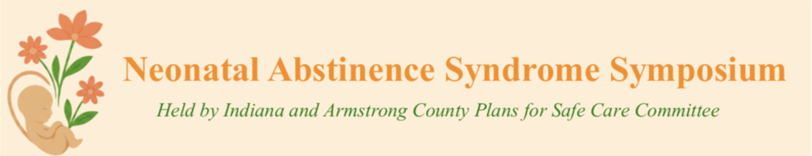


PA PQC Armstrong & Indiana County NAS Symposium
Friday, October 9, 2027
9:00 a.m. to 3:00 p.m. ET
IUP Kovalchick Convention & Athletic Complex
Indiana, PA

Learning Objectives:

- Describe how effective identification and provision of compassionate, trauma informed care and coordinated community supports can improve outcomes for infants affected by Neonatal Abstinence Syndrome and their families

Agenda:

8:00 a.m. to 9:00 a.m. – Registration and Breakfast

9:00 a.m. to 9:15 a.m. – Welcome and Opening Remarks – Hillery Cramer, Family Resource Specialist, Armstrong and Indiana County Plans of Safe Care Committee

9:15 a.m. to 10:15 a.m. – Neonatal Abstinence Syndrome in Pennsylvania: What the PA DOH's 2024 surveillance data tell us about incidence, equity, and the shift to Eat, Sleep, Console – Vinit Manual, MD, Allegheny Health Network

10:15 a.m. to 10:30 a.m. – Break

10:30 a.m. to 11:30 a.m. – Beyond Discharge: Creating a Continuum of Care for Infants with NAS – Sara Mills-Huffnagle, MS, PhD, Penn State Health

11:30 a.m. to 12:30 p.m. – Lunch & Networking

12:30 p.m. to 1:30 p.m. – Birthing People, Substance Use and Domestic Violence – Mae Reale, MA, Health Education Specialist, PA Coalition Against Domestic Violence

1:30 p.m. to 1: 45 p.m. – Break

1:45 p.m. to 2:45 p.m. – Lived Experience Panel – Facilitated by Elica Shaw, MSW, ARMOT Case Manager, Armstrong Indiana Clarion Drug & Alcohol Commission
- Panelists: Erica Pope • Kerry Johnson • Mike Vavrek • Stasha Ray

2:45 p.m. to 3:00 p.m. – Closing Remarks – Hillery Cramer, Family Resource Specialist

