Welcome to Ethos Course Creation from Beginning to End

Let’s begin with a New Course Application
Once your account is created, you are able to submit an application by clicking New Course Application

Standard timeline for Nurse Planners: Please keep in mind that according to accreditation requirements, the accredited provider (i.e., you on behalf of CCEHS) must be involved early in the planning of the activity and applications should be submitted early in the planning stages and at least 60 days prior to the activity date. Please allow 10 business days for CCEHS to review the application. Notifications will be provided by email and are available under Activity Applications in your account.
Exception: If you have been involved in the planning of the activity, we will accept applications submitted up to 10 business days prior to the activity, other exceptions considered as requested. We cannot guarantee approval.
Flexibility cannot be granted in the following scenarios:
- The course is jointly sponsored (i.e. you are working with an external organization).
- The course is receiving funding (e.g., grants, sponsorships, exhibits) from an ineligible company (i.e., commercial interest). Refer to Guidance on Receiving Fund and Managing Marketing by Ineligible Companies_2022.pdf (upmc.com).
- The planning committee has not provided disclosure information or has identified relationships with a commercial interest.
Notes and Tips for submitting the application:
- There are 7 tabs/pages to the application. After each page click on "Save Draft" if you are not ready to continue. If you are ready to move to the next page, click on “Next Tab”.
- If you have forgotten to complete any of the sections, you will not be given the option to “Submit” at the at the end of the application.
- You are required to submit planning committee disclosure information at the time the application is submitted.
- Once the application is submitted, you will receive an email from CCEHS that your application has been submitted. Please DO NOT begin creating the course until the application is APPROVED. Once your application has been approved, you will receive another email from CCEHS stating your program is ready for review.
- Don’t forget to answer this question. You will not be able to submit unless you click Yes.
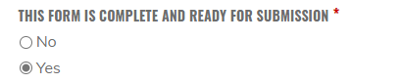

Let’s Create and Build a Course

Step One: CREATING A COURSE
Access the APPROVED course application.
-In the approval email, choose “Click here to review” OR
-In your account, choose My Activities, My application

Select Create Activity. Choose Course and then Convert.
Note: You are not allowed to create a Series.

At this point so your course is created.

Step Two: BUILDING A COURSE
From the course page, choose Edit. Complete each of the Horizontal Tabs.
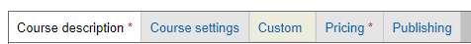

Note the following before building the course:
- If you have left the course and want to resume editing, access the course from the application (View Activity) OR from the Wrench, choose Ethos CE Admin, Manage Content. Tip: filter by Title, Type and Author (you).
- If you choose Save after each tab, it will take you out of the course (choose Edit to resume building the course). But if you don’t Save and inadvertently “x” out you will lose everything.

From the instructions below, * are required fields (even though the fields may not be required in Ethos)

It may be helpful to open the application in a separate tab to use as a reference.

Tip: If you are copying/pasting from other documents, to maintain the consistent font in Ethos you can paste into Notepad, then copy/paste from Notepad to Ethos to remove the existing formatting.

COURSE DESCRIPTION TAB

Title and Description
*Title. Review the title and make sure it is correct. Note: If this is a repeating course, add the date to the title.

*Program description. Provide a description of the course. Note: This is also the default for what is used on the course catalog and the automated calendar request in the confirmation email.

Program description (edit summary). Leave blank if it is not applicable to these 2 purposes:
1.) If are choosing to have the course on the course landing page, it will override whatever is listed in the program description and use this text instead on the course catalog.
2.) It populates the automated calendar request in the confirmation email.

Course Image. If you are advertising on the course landing page, you have the option to upload an
image to appear in line with the course title and description.

*Target Audience. At a minimum, the target audience must represent the credits being awarded.

*Learning objectives. Enter learning objectives. Tip: Copy and Paste from application.

*Accreditation: If ANCC is the only type of credit, use the statement below, copy and paste the following:

In support of improving patient care, the University of Pittsburgh is jointly accredited by the Accreditation Council for Continuing Medical Education (ACCME), the Accreditation Council for Pharmacy Education (ACPE), and the American Nurses Credentialing Center (ANCC), to provide continuing education for the healthcare team.

The maximum number of hours awarded for this Continuing Nursing Education activity is __ contact hours.

Other health care professionals will receive a certificate of attendance confirming the number of contact hours commensurate with the extent of participation in this activity.

Note: Refer to the Accreditation and Credit Designation Guidelines for other types of credit, Accreditation and Credit Designation Guidelines.docx (live.com).

*Date & Time (IMPORTANT read carefully)
Start date:
- Live activity using the CCEHS registration system, this is the earliest date and time you want registration to be available.
- Live activity not using the registration system, this is the date that you want the evaluation/credit to be available (generally the date of the course).
- Enduring material, this is the date the activity is available to be accessed.

End date:
- Live or virtually live activity, the end date is the date that you want the evaluation/credit to end (i.e. not accessible). This should not be more than 30 days past the event date. Tip: Although you are allowing 30 days, instructions to attendees should be 2 weeks to complete the evaluation/claim credit to allow for late completions.
- Enduring material, this is the date that the course will expire.

*Check the Live button for a live (in person) course.
- The event date is the start and end date and times of the live (in person) or virtually live course. Note: registration using Ethos automatically expires 4 hours after the start time. For example, if a course starts at 8 AM, a person cannot register for the course at 1:00 PM.

Faculty & Disclosure.
*Enter faculty/speaker information: Name, Degree, Affiliation (at a minimum), if you are using Ethos for
Audience Disclosure (refer to Audience Disclosure Guidelines) you must include the COI Disclosure Statement.

Skip Disclosure Link.

Course Format & Instructions.
*Format:
- Conference (choose for a live conference)
- Virtual Conference
- Webinar (live)
- Hybrid
- Self-study/Enduring Material.

Note: The remaining fields will be included in specific sections of the course landing page and are optional depending on whether or not you are using the registration system, or these fields may be useful to provide additional instructions for an enduring material.

Required hardware/software: This is rarely applicable.

Course Instructions: Anything entered in this field will appear after the person chooses “Register”.

Registrations Instructions: Anything entered in this field will appear on the Register tab.
Course Completion Message: Anything entered in this field will appear after a person finished the required objects/course.

*Program. This is the course agenda including start/stop/break/lunch times as applicable.

*Marketing. ALWAYS check Nobody may rate this activity. No other information needs added on this screen.

*Venue. The certificate uses information from this section.
- Must include Location
- If live (in person) or a combination of live (in person) and virtual, City /State are required.
- If virtual only, enter “Virtual” in the City and leave State blank or enter City/State (either way is fine)
- Additional information (specific address) can be included to provide directions, etc.

Exhibitors. This is an optional field to inform potential companies if you are soliciting exhibitors. Reminder: you must contact CCEHS prior to soliciting any support from a commercial interest, including exhibitors.

File Attachments. Optional to attach (save to your computer, then click Upload) any documents that you would like to be accessible (e.g., brochure, handouts). Note: if the course is on the CCEHS catalog, it will be accessible to anyone.

COURSE SETTINGS TAB
Course Settings.

Outline Display: Always Course.

*Enrollment Type: Choose Course unless you are using the registration system and want to add enrollment questions such as dinner options. To use enrollment questions, reach out to CCEHS for assistance.

Duration: ALWAYS SKIP--- this causes a lot of problems if you enter anything.

*External Course ID: Please read carefully because this is not intuitive. The external ID is the 5-digit Node ID. Unfortunately, when you are creating a course from the Application (this process), the only way to find the Node ID is in the html web address at the top of the page. Example: Nursing_81865

Show on catalog: Only check if you want the course to appear on the CCEHS home page and have included information on how to register.
Reminder: Following the course, you need to uncheck “Show on Catalog”. The course is not automatically removed.

Show on calendar: Always uncheck.

Show on Transcript: Always check.
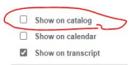

Course Credit.

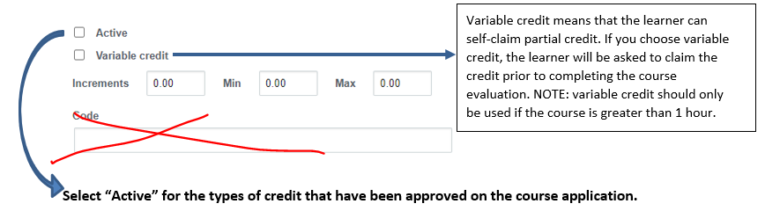
- Nursing CNE =ANCC
- Physician CME =AMA
- Physician Assistant =AAPA
- Attendance (always include) =Attendance credit will be awarded to anyone who is not awarded the other types of credit
- Social Work CE =ASWB Requires additional information. Do not select unless the credit has been approved AND you have talked to your CCEHS contact.
- Pharmacist CPE =ACPE Requires additional information. Do not select unless the credit has been approved AND you have talked to your CCEHS contact.

Notes:
Change the increments to .25 for ANCC credit.
Do not enter anything in the “CODE” field.
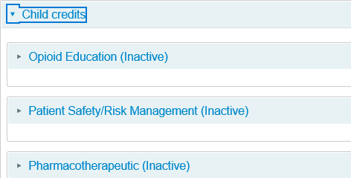
- Child credits are special designations that will appear on the learner’s transcript. For example, if applicable, you could choose “Pharmacotherapeutic” for contact hours that meet this specific designation. Do not select unless you have talked to your CCEHS contact.
Certificate. IMPORTANT (please read carefully)

This section is already defaulted for live programs so do not change (see exceptions below).

Please do not change unless the course qualifies as one of the exceptions.

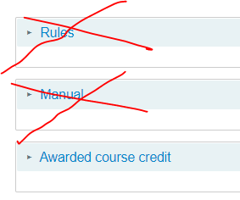

Exceptions:

Multi-day live course, choose Awarded course credit and change the certificate to “multi-day live-“ for each type of credit awarded. This will ensure the start and end date are included on the certificate.

Enduring material/self-study, choose Awarded course credit and change the certificate to “enduring material-“ for each type of credit awarded.
Pre-requisites Tab. Skip this section.
Exception: if you are interested in enforcing pre-requisites such as passing a test or entering a code prior to a learner registering for a live course or accessing an enduring material, please contact CCEHS.

- CUSTOM TAB
This tab includes two features that are customized for CCEHS.

- UPMC accounting information for courses accepting tuition. Contact CCEHS If you are interested in using the registration system. If not applicable, skip this section.
Important: leave blank if you are not accepting tuition using the registration system. Do not enter all zeroes.
NEW

- The purpose of this section is to maintain final documentation required for accreditation purposes. It is the responsibility of the person assigned to this activity to upload all final documents within 30 days post-course.
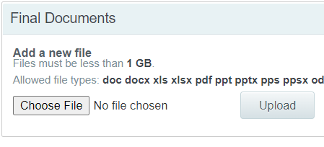
Required documents include:
- Evidence of audience disclosure
- All COI disclosure forms
If applicable:
- Management of COI Grid,
- All marketing materials
- Course budget, if commercial funding is received
- Evaluation summary, if Ethos was not used for evaluation
- Enduring Materials Only: Content (i.e., MP4, PPT)
- Exhibitor agreements
- Letters of Agreement for Commercial Support
Any other relevant materials.

This field can only be accessed and viewed by people assigned a specific role in Ethos (i.e., CCEHS Staff, Nurse Planners, etc.).

- PRICING TAB. Skip the pricing tab.

- PUBLISHING TAB.
Warning: This Tab is filled with options that can cause problems. Only use the fields highlighted below.
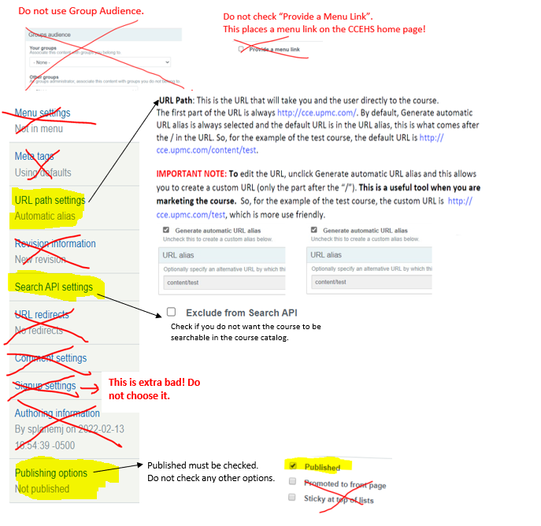

SAVE! Do not proceed without saving or you will lose everything!

Step Three: ENROLLMENTS

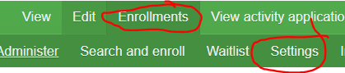

The following settings are applicable to course registration:

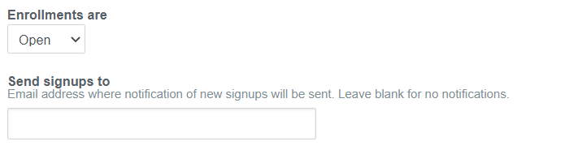
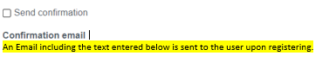
Below is a sample email. Be careful to consider your specific scenario and include details that may be applicable.

Thank you for participating in “[node:title]”. To receive credit, following the activity, login to your account at http://cce.upmc.com to claim credit and complete the evaluation. The course will be in your Pending Activities and accessible immediately following the activity. Certificates will be available to download and stored for future reference in your Completed Activities.

Note: The system sends an outlook calendar item with the confirmation email including the information ended in the Program Description Summary (in course Edit mode). It is by default and cannot be removed. The user has the option to select it or ignore it.

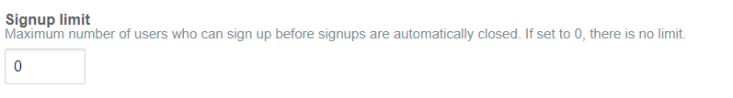

Step Four: COMPLETING COURSE OUTLINE

The course outline manages the requirements (course objects) for completing the course.

If you are already in “Edit” mode for the course, you will see a green toolbar, choose Course Outline.

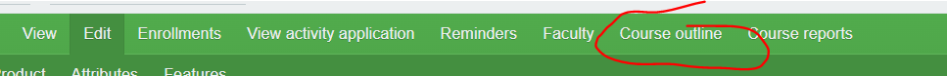

Otherwise, from the course landing page, choose Course Outline.

For a typical live course, the learner will:

complete the course evaluation (Webform Object)

claim credit (Credit Object)

get a certificate (Certificate Object)

For a typical enduring material, the learner will:

watch video (Course Page Object

complete the course evaluation (Webform Object)

complete a quiz (Quiz Object)

claim credit (Credit Object)

get a certificate (Certificate Object)

For all Activities add Certificate and Webform objects. The Credit Object will automatically appear by default.

Add Certificate. Add "Certificate" in the title. You do not need to do anything else in the certificate settings.
Click Update.

Add Webform. This is the course evaluation.
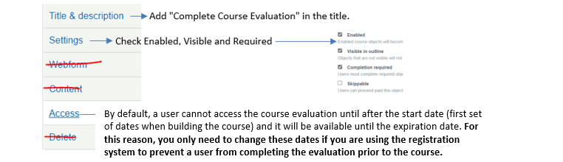

Click Update.

For an enduring material:
Add Course Page (if content is being viewed in Ethos). This is where you will insert the video link. Add "View Module" or something similar in the title. Your CCEHS contact will help you format video content.
Click Update.

Add Quiz. Add "Take Quiz" or something similar in the title. Your CCEHS contact will help you format the quiz.
Click Update.

The order of items (as applicable) the learner is to complete are as follows:
- Course Page (video content)
- Quiz
- Evaluation
- Credit
- Certificate

It is important to place these in the correct order. This is the order that the learner will complete the requirements.
Tip: Double check these settings because they may revert back to the original order if you make changes.

Click and drag the cross of the section to reflect correct order of completion.
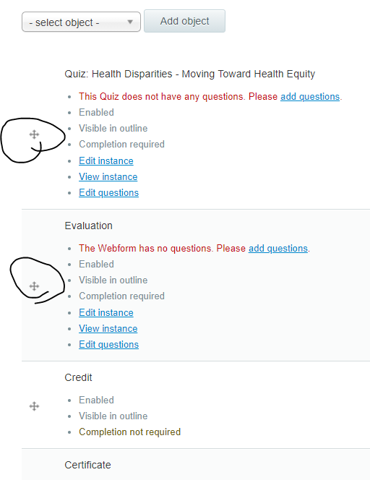

CLICK SAVE – if you forget to save the order will not be saved.

Step Five: CREATING THE EVALUATION

The next step is to add the course evaluation template. From the "Complete the Course Evaluation" object choose Edit Instance. If you don’t see this option, it is likely that you didn’t save the outline.

Select the appropriate template.
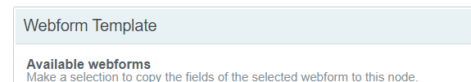
Start typing “Evaluation” to populate the available templates.
Choose one of the following:
- Interprofessional Evaluation With Speakers
- Interprofessional Evaluation Without Speakers

Do not make any changes. CLICK SAVE (bottom of the page)

Edit Questions.
The next step is to edit the course evaluation questions (e.g. add dates, speakers, custom questions).
You should be back in the Course Outline. Choose Edit Questions in the Course Evaluation Object.

Note: This step gives you the option to edit the speaker section, if applicable, and the overall
Assessment. To duplicate a section (e.g., adding an additional day for a multi-day course or add
a custom section), you can use the cloning function.
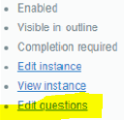
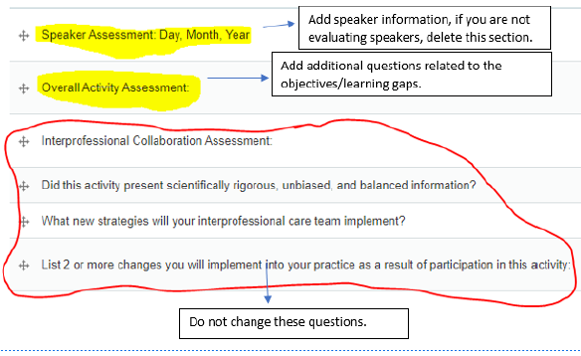

Edit Speaker Assessment.
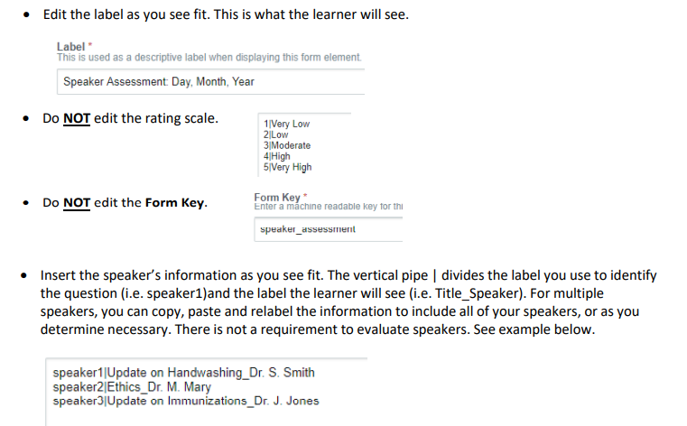
Click Save
Edit Overall Activity Assessment.
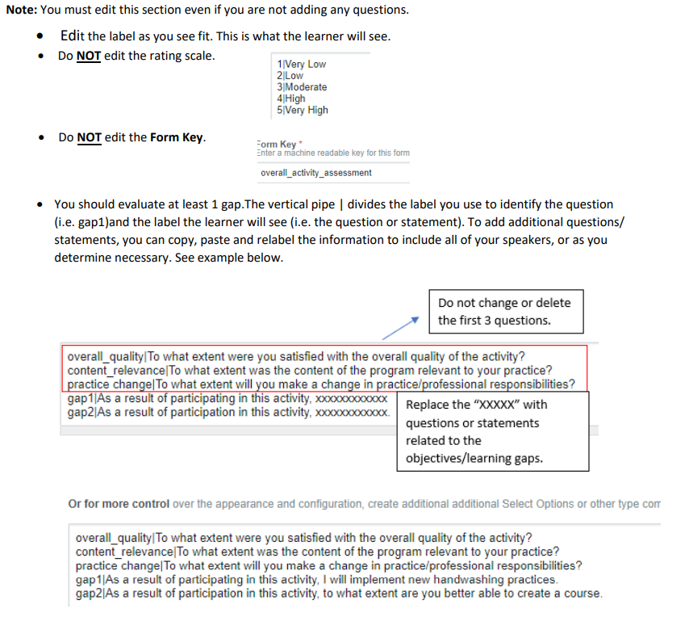

Click Save. Course Evaluation is completed (You can view evaluation by clicking on View Instance.
Return to the Course Outline. Check to ensure it is in the correct order. Click Save Outline.
*At this time, your course should be complete unless you need to configure a quiz or video content.

